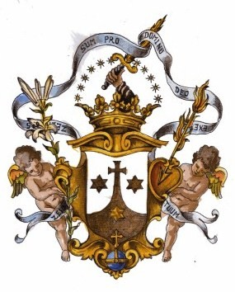
THE REFORMED CATHOLIC CHURCH
CARMELITE FRIARS OF THE DIVINE MERCY
APOSTLES OF MERCY
ST. ELIJAH MONASTERY
A contemplative –semi-cloistered religious community
Founded 2010

RULE –CONSTITUTION--BYLAWS

The community in which fraternal charity reigns will truly
experience the presence of Christ, as He vivifies and enhances it
with the gift of His Holy Spirit. Then it will bear witness to God´s
all-embracing merciful love, become a sign of universal brotherhood and proof
of the powerful influence exerted by love, justice and peace
the Gospel brings with it.

Prepared by:
Br. José Israel de la Trinidad, DD AoM.
Prior General
2010

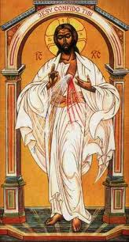
The Apostles of Mercy
is a contemplative community of priests, religious men and consecrated laity.

As with each religious community, their presence enriches our Church with the graces and fruits of the special life to which they have been called. In the case of the Reformed Carmelites of the Divine Mercy, they have been called to live a life of faith in Jesus, the eternal Mercy of God, revealed in the gospel and providentially recalled through the revelations given to Saint Faustina Kowalska.

This faith leads them to a trusting abandonment of the Will of the Father. With our Blessed Mother, they are called to a contemplative life of prayer and recollection, of ¨abiding in His Love¨ and interceding for the world. This contemplative life can be hard to understand and harder to find in our busy and restless society. But this life, dedicated to ¨the one thing necessary¨, permits an action of God´s grace beyond any merely human possibilities.

In the Apostles of Mercy, life and apostolate, a priority is given to the Holy Sacrifice of the Mass and adoration of the Blessed Sacrament. The Apostles of the Divine Mercy seek to carry out its apostolic dimension by sharing their spirit with others—in their different ministries. They wish to help all to discover the Holy Spirit´s invitation to a deeper union with Him. The lay branch are men and women, single or married, who will endeavor to bring this spirit into the world where they live.

The Apostles will promote a retreat center and a sanctuary of Divine Mercy where others can come to take part in their community prayer, participate in the various retreats and spiritual formation activities or simply come to experience God´s Mercy amidst the trials of our world today.

¨Mankind will not have peace until it turns to My mercy¨, said the Lord to Saint Faustina. His Mercy is our great hope and needs to be widely promoted.

CARMELITE FRIARS OF THE DIVINE MERCY
APOSTLES OF MERCY

MISSION

Incardinated in the Reformed Catholic Church
The Carmelite Friars of the Divine Mercy
Apostles of the Divine Mercy
will communicate through their humble service to others
their experience of friendship, brotherhood and intimacy with the Lord,
that they wish to live daily through prayers,
as Silent Pilgrims living in oblation to Jesus Christ
and to his Divine Mercy.

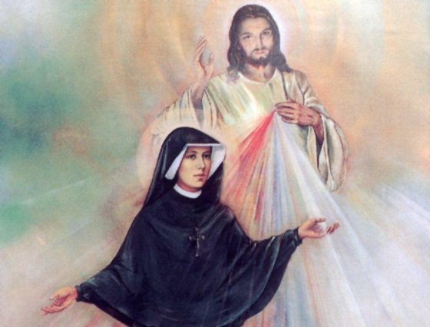

DOCTRINES OF FAITH

POSTULADOS DE FE

THE REFORMED CATHOLIC CHURCH

We believe that Jesus is the Christ and our personal savior.
Creemos que Jesus es el Cristo y nuestro salvador personal.
We believe in The Holy Trinity.
Creemos en la Santísima Trinidad.
We believe in the three historic creeds: Nicene, Apostles and Athanasian.
Creemos en los tres credos históricos: Niceno, de los Apóstoles y el Atanasio.
We believe in the inerrancy and divine inspiration of Holy Scriptures.
Creemos en la inspiración divina de las Sagradas Escrituras.
We believe in the seven sacraments of the Church: Baptism, Confirmation, Holy Eucharist, Anointing and Prayers for the Sick, Confession and Reconciliation, Marriage, and Holy Orders.
Creemos en los siete sacramentos de la Iglesia: Bautismo, Confirmación, Sagrada Eucaristía, Unción de los Enfermos, Reconciliación, Matrimonio y Órdenes Sagradas.
We believe that all Holy Orders (deacons, priests, and bishops) are to be open to both men and women
Creemos que todas las Órdenes Sagradas (diáconos, sacerdotes y obispos) deben estar disponibles a ambos, hombres y mujeres.

We believe that celibacy of those in Holy Orders is a personal decision.
Creemos que la celibacía para aquellos que están en las Órdenes Sagradas ha de ser una decisión personal.

We believe and accept the doctrines of the Seven Early Church Ecumenical Councils.
Creemos y aceptamos las doctrinas de los primeros siete Concilios Ecuménicos de la Iglesia Primitiva.

We believe and hold apostolic succession. Creemos y sostenemos nuestra Sucesión Apostólica.
We believe and appreciate the wisdom and guidance of the Early Church Fathers
Creemos y apreciamos la sabiduría y guía de los Padres Primitivos de la Iglesia.

We appreciate the wisdom and guidance of the founding Fathers of the Old Catholic Movement as expressed in historic documents of the Old Catholic Churches o Europe, particularly the Declaration of Utrecht.
Apreciamos la sabiduría y guía de los Padres Fundadores del Antiguo Movimiento Católico, según expresado por los documentos históricos de las Antiguas Iglesias Católicas de Europa, particularmente las de la Declaración de Utrecht.
We are an inclusive church. We welcome all the children of God.
Somos una iglesia inclusiva. Recibimos a todos los Hijos de Dios
marginados por nuestra sociedad, reconociendo que somos
todos hijos de un mismo Padre.
We believe in the responsible stewardship of our planet.
Creemos que somos responsables por la conservación de nuestro planeta.

We believe in the One Holy Catholic and Apostolic Church.
Creemos en la Iglesia, Una, Santa, Católica y Apostólica.

We believe in the sanctity of marriage, however we believe
that Jesus is merciful and those who have been divorced and/or remarried are offered the sacraments of the church.
Creemos en la santidad del matrimonio, no obstante, creo que Jesús es misericordioso y que aquellos que se han divorciado Y/O vueltos a casar deben poder recibir los sacramentos de la Iglesia.

We believe that family planning is a personal decision between a husband and wife.
Creemos que la planificación familiar es una decisión entre el esposo y su esposa.
We believe and follow scripture in all matters.
Creemos y seguimos las Sagradas Escrituras en todas los asuntos
We believe in the scriptural teaching of Jesus Christ.
Creemos en las enseñanzas de Jesucristo conforme a las Escrituras.

HISTORY OF THE CARMELITES

Origins of the Carmelite Order
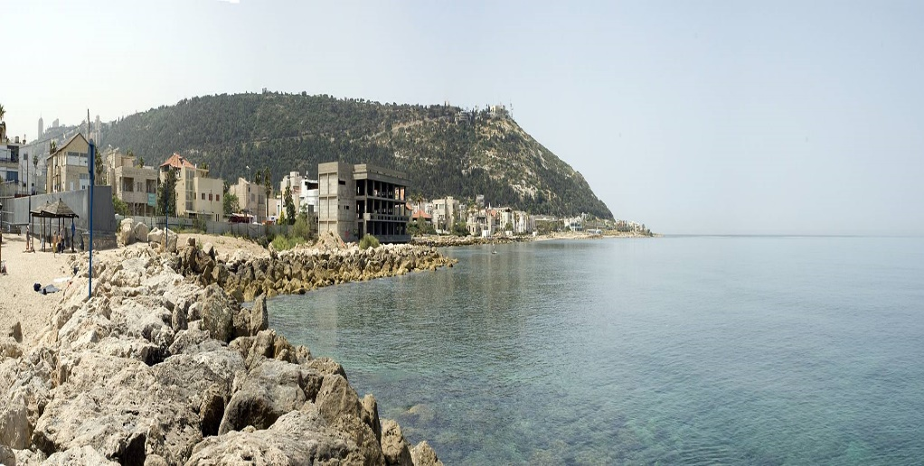
A view of Mount Carmel today.
The Carmelites have a unique background. Unlike most Religious Orders, we have no founder. Earliest historical
accounts find the first Carmelites already settled as Christian hermits on Mount Carmel - a mountainous ridge in
Israel-Palestine - around the year 1200 (i.e. some 800 years ago). The hermits lived by the fountain or well of the
prophet Elijah (whose exploits on Carmel are described in the Bible's Books of the Kings).

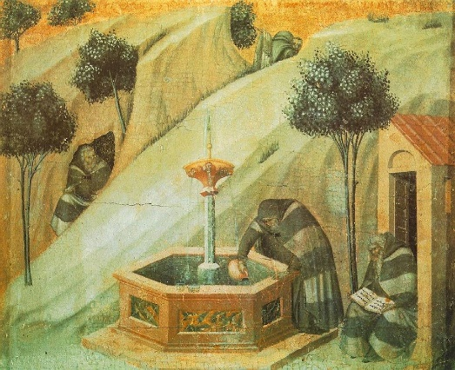
The hermits gathered around the Well of Elijah on Mount Carmel, painted by Pietro Lorenzetti between 1328-29 as part of an altarpiece for the Carmelite Church in Siena, Italy, now at the Pinacoteca in Siena.
The chapel which stood amid the hermits' cells was dedicated to Mary, the Mother of Jesus. The process of change from a small band of hermits to a worldwide family did not happen overnight.

At the time of the Crusades to the Holy Land, hermits settled in various places throughout Palestine. Some of these, "following the example of Elijah, a holy man and a lover of solitude, adopted a solitary lifestyle on Mount Carmel, near a spring called Elijah's Fountain. In small cells, similar to the cells of a beehive, they lived as God's bees, gathering the divine honey of spiritual consolation."

Later, St. Albert, Patriarch of Jerusalem brought the hermits together, at their request, into a single "collegium"; he gave them a formula for living which expressed their own eremitical ideals ("propositum") and reflected the spirit of the so-called pilgrimage to the Holy Land and of the early community of Jerusalem. Moved by "their love of the Holy Land", these hermits consecrated themselves in this Land to the One who had paid for it by the shedding of his blood, in order that they might serve him, clothed in the habit of religious poverty," persevering "in holy penance" and forming a fraternal community.

This way of life was approved successively by Honorius III in 1226, by Gregory IX in 1229, and by Innocent IV in 1245. In 1247, Innocent IV approved of it definitively as an authentic rule of life, amending it to suit Western conditions. These adaptations became necessary when the Carmelites began to migrate to the West to escape persecution and expressed a desire to lead a life "in which, with the help of God, they would have the joy of working for their own salvation and that of their neighbor."

As a result of the approval of the Rule by Innocent IV, the Carmelites placed themselves at the service of the Church, according to the common ideal of the Mendicant Orders...
So, we have no Francis or Dominic or Benedict (or even a Teresa as have the Discalced Carmelites) to whom we can look as a founder. This means that God's founding gift to the Order (the 'Charism') is not found in a person or a particular book but in a community of people. Being without a founder, the Carmelites have continually looked to the great figures of Elijah and Mary for inspiration - remember we settled by the Well of Elijah on Carmel and dedicated the first chapel to the Mother of God. Throughout our history, these key figures have helped us clarify our identity and renew our spirit. They provide a wonderful integration of the two streams of the contemplative Carmelite tradition: prayer blended with active service; meditation combined with prophecy; reflection informed by and informing apostolic work.
As human models, Elijah and Mary provide Carmelites with an example to imitate. Not unlike Carmelites of any era, they struggled with fear, stood in the face of very difficult questions, and felt deeply the pains of human life. Being human, they appear like us, as fragile and vulnerable. Yet they were filled with deep conviction. It is a conviction that lies at the heart of the Carmelite spirit: God is alive! God is present! God is with us! - in the words of the Prophet Elijah "God lives, in whose presence I stand".
Between the years 1206 and 1214, the community on Mount Carmel petitioned Albert, the Latin Patriarch of Jerusalem, for a rule of life. His response became the "formula for living" that Carmelites follow to this day as the Rule of Saint Albert. This short but profound document inspires all branches of the Carmelite Family to this day.

Hospitality was no doubt one of the original values for the early Carmelites. Mount Carmel served as a place of rest for pilgrims in the Holy Land. Some of them were so impressed by the beauty of Carmel and the simple lifestyle of the community of hermits who lived there that they stayed.
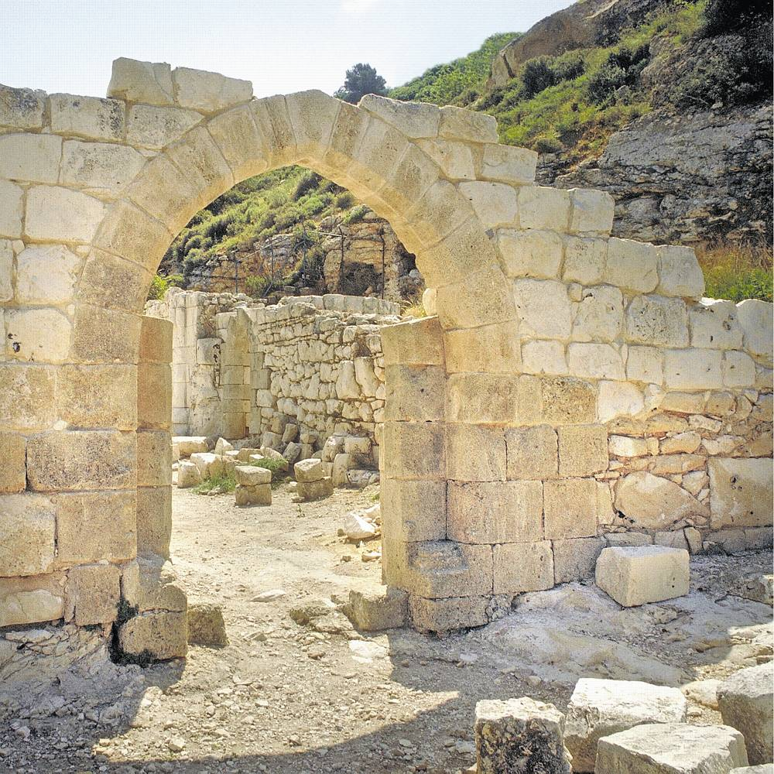
The ruins of the oratory or chapel on Mount Carmel.

Soon after they received Albert's Rule, the Carmelites were forced to leave the known slopes of Carmel
and settle in Europe. Probably many of the first Carmelites had been crusaders or pilgrims and they
naturally headed for their own countries. Like ripples in a lake Carmel spread first to Cyprus, then to France,
and then to England in 1242.

Adaptation and flexibility were demanded as the Carmelites not only changed their place of residence but also modified their style of life - from desert to city, from hermit to friar. Assuming the mendicant tradition, Carmelites went wherever they were needed, serving God's people and sharing the spirit of Carmel.

Prayer is at the core of the Carmelite spirit. To grow in friendship with God, to experience God's love, to ponder the mystery and wonder of life, to search for meaning - all encompass the contemplative dimension of Carmelite life.

In the solitude of prayer, we experience the compassion of God which enables us to live in solidarity with our brothers and sisters. This experience makes ministry possible. It empowers us to "suffer with" and respond to those in deed. It also enables us to be patient with and forgive each other.

How Carmelites serve is not set in stone. As friars, we respond to the needs of the Church in a variety of ways. Today we can be found in parishes, schools, retreat houses, on campuses, in hospitals, in prisons, in both rural and urban settings. What we do today, we may not have done in the past. The same holds true for the future. Depending on the need, Carmelites will respond - continually following in the footsteps of Jesus Christ.
Carmelites are ordinary people who witness an extraordinary reality - the abiding presence of God. To live in the presence of God gives the ordinary things we do great meaning. It was the motivating force for Elijah whose spirit continues - "the Lord lives, in whose presence I stand" and "with zeal, have I been zealous for the Lord God of Hosts."

Carmelite Shield


The shield is made up of a mountain in brown and three stars. The mountain is Mt. Carmel in Palestine where the Carmelite Order came into being. It was on Mt. Carmel that Elijah sought intimacy with God.
In the coat of arms shown above, the lowest star represents the Blessed Virgin Mary, the Star of the Sea. Two upper stars represent Elijah and Elisha. These three stars point to the Marian Character of the Carmelite Order and to its Elijah descent. Other Carmelite coats of arms provide different symbolism.



THE RULE OF SAINT ALBERT

As approved by Innocent IV (1247).

One of the shortest of the great rules is the one originating with St. Albert of Jerusalem (d.1214), who gave the Carmelites a Way of Life. His legislation has come down to the Carmelite Order with some modifications sanctioned by Innocent IV in Quem honorem (1247), which scholars today see as constituting it as a rule. This Rule inspires the whole worldwide Carmelite family.
[1] Albert, called by God's favor to be patriarch of the church of Jerusalem, bids health in the Lord and the blessing of the Holy Spirit to his beloved sons in Christ, B. and the other hermits under obedience to him, who live near the spring on Mount Carmel.
[2] Many and varied are the ways in which our saintly forefathers laid down how everyone, whatever his station or the kind of religious observance he has chosen, should live a life of allegiance to Jesus Christ -- how, pure in heart and stout in conscience, he must be unswerving in the service of his Master.
[3] It is to me, however, that you have come for a rule of life in keeping with your avowed purpose, a rule you may hold fast to henceforward; and therefore:
[4] The first thing I require is for you to have a prior, one of yourselves, who is to be chosen for the office by common consent, or that of the greater and mature part of you; each of the others must promise him obedience -- of which, once promised, he must try to make his deeds the true reflection -- and also chastity and the renunciation of ownership.
[5] If the prior and brothers see fit, you may have foundations in solitary places, or where you are given a site that is suitable and convenient for the observance proper to your Order.
[6] Next, each one of you is to have a separate cell, situated as the lie of the land you propose to occupy may dictate, and allotted by disposition of the prior with the agreement of the other brothers, or the more mature among them.
[7] However, you are to eat whatever may have been given you in a common refectory, listening together meanwhile to a reading from Holy Scripture where that can be done without difficulty.

[8] None of the brothers is to occupy a cell other than that allotted to him or to exchange cells with another, without leave or whoever is prior at the time.
[9] The prior's cell should stand near the entrance to your property, so that he may be the first to meet those who approach, and whatever must be done in consequence may all be carried out as he may decide and order.
[10] Each one of you is to stay in his own cell or nearby, pondering the Lord's Law Day and night and keeping watch at his prayers unless attending to some other duty.
[11] Those who know how to say the canonical hours with those in orders should do so, in the way those holy forefathers of ours laid down, and according to the Church's approved custom. Those who do not know the hours must say twenty-five Our Fathers for the night office, except on Sundays and solemnities when that number is to be doubled so that the Our Father is said fifty times; the same prayer must be said seven times in the morning in place of Lauds, and seven times too for each of the other hours, except for Vespers when it must be said fifteen times.
[12] None of the brothers must lay claim to anything as his own, but you are to possess everything in common; and each is to receive from the prior -- that is from the brother he appoints for the purpose -- whatever benefits his age and needs.
[13] You may have as many asses and mules as you need, however, and may keep a certain number of livestock or poultry.
[14] An oratory should be built as conveniently as possible among the cells, where, if it can be done without difficulty, you are to gather each morning to hear Mass.
[15] On Sundays too, or other days, if necessary, you should discuss matters of discipline and your spiritual welfare; and on this occasion the indiscretions and failings of the brothers, if any be found at fault, should be lovingly corrected.
[16] You are to fast every day, except Sundays, from the feast of the Exaltation of the Holy Cross until Easter Day, unless bodily sickness or feebleness, or some other good reason, demands a dispensation from the fast; for necessity overrides every law.
[17] You are to abstain from meat, except as a remedy for sickness or feebleness. But as, when you are on a journey, you often must beg your way; outside your own houses you may eat foodstuffs that have been cooked with meat, so as to avoid giving trouble to your hosts.
At sea, however, meat may be eaten.
[18] Since man's life on earth is a time of trial, and all who would live devotedly in Christ must undergo persecution, and the devil your foe is on the prowl like a roaring lion looking for prey to devour, you must use every care to clothe yourselves in God's armor so that you may be ready to withstand the enemy's ambush.

[19] Your loins are to be girt with chastity, your breast fortified by holy meditations, for, as Scripture has it, holy meditation will save you. Put on holiness as your breastplate, and it will enable you to love the Lord your God with all your heart and soul and strength, and your neighbor as yourself. Faith must be your shield on all occasions, and with it you will be able to quench all the flaming missiles of the wicked one: there can be no pleasing God without faith; [and the victory lies in this -- your faith]. On your head set the helmet of salvation and so be sure of deliverance by our only Savior, who sets his own free from their sins. The sword of the spirit, the word of God, must abound in your mouths and hearts. Let all you do have the Lord's word for accompaniment.
[20] You must give yourselves to work of some kind, so that the devil may always find you busy; no idleness on your part must give him a chance to pierce the defenses of your souls. In this respect you have both the teaching and the example of Saint Paul the Apostle, into whose mouth Christ put his own words. God made him preacher and teacher of faith and truth to the nations: with him as your leader you cannot go astray. We lived among you, he said, laboring and wary, toiling night and day so as not to be a burden to any of you; not because we had no power to do otherwise but to give you, in your own selves, an example you might imitate. For the charge we gave you when we were with you was this: whoever is not willing to work should not be allowed to eat either. For we have heard that there are certain restless idlers among you. We charge people of this kind and implore them in the name of our Lord Jesus Christ, that they earn their own bread by silent toil. This is the way of holiness and goodness: see that you follow it.
[21] The Apostle would have us keep silence, for in silence he tells us to work. As the Prophet also makes known to us: Silence is the way to foster holiness. Elsewhere he says: Your strength will lie in silence and hope. For this reason I lay down that you are to keep silence from after Compline until after Prime the next day.
At other times, although you need not keep silence so strictly, be careful not to indulge in a great deal of talk, for, as Scripture has it -- and experience teaches us no less -- sin will not be wanting where there is much talk, and he who is careless in speech will come to harm; and elsewhere: The use of many words brings harm to the speaker's soul. And our Lord says in the Gospel: Every rash word uttered will have to be accounted for on judgment day. Make a balance then, each of you, to weigh his words in; keep a tight rein on your mouths, lest you should stumble and fall in speech, and your fall be irreparable and prove mortal. Like the Prophet, watch your step lest your tongue give offence, and employ every care in keeping silent, which is the way to foster holiness.
[22] You, brother B., and whoever may succeed you as prior, must always keep in mind and put into practice what our Lord said in the Gospel: Whoever has a mind to become a leader among you must make himself servant to the rest, and whichever of you would be first must become your bondsman.
[23] You, other brothers too, hold your prior in humble reverence, your minds not on him but on Christ who has placed him over you, and who, to those who rule the Churches, addressed the words: Whoever pays you heed pays heed to me, and whoever treats you with dishonor, dishonors me; if you remain so minded you will not be found guilty of contempt, but will merit life eternal as fit reward for your obedience.
[24] Here then are the few points I have written down to provide you with a standard of conduct to live up to; but our Lord, at his second coming will reward anyone who does more than he is obliged to do. See that the bounds of common sense are not exceeded, however, for common sense is the guide of the virtues.

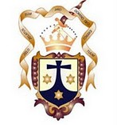

RULE OF LIFE
CARMELITE FRIARS OF THE DIVINE MERCY
APOSTLES OF MERCY

Foundation

In the name of the Lord, the life of the Apostles of Mercy begins.

The rule and life of the brothers of the Apostles of Mercy is this;

To observe the holy gospel of our Lord Jesus Christ, living in chastity and obedience without anything of our own; desiring to be founded on holy humility, and to imitate pure simplicity, holy Prayer and poverty.

To live a life of allegiance to Jesus Christ and to serve him faithfully, with a pure heart and a clear conscience.

Brother Jose Israel de la Trinidad promises obedience and reverence to the Presiding Bishop of the Reformed Catholic Church as representative of the One Holy Catholic Apostolic Church. The Apostles of Mercy are obliged to obey the Presiding Bishop and the Diocesan Bishops in which our communities are present.

The Apostles of the Divine Mercy look to Saint Faustina Kowalska, Apostle of the Divine Mercy as our guide to their living out the Gospel of our Lord Jesus Christ. We are to become faithful promoters of the devotion to the Divine Mercy of Jesus as promised by him to St. Faustina.

In seeking our duty, we also turn to Saint Therese of Avila who was called by God to reform his church. We see ourselves doing our small part in repairing the Church into a more inclusive Church through a life which announces in word and action the Infinite and Divine Mercy and Love of Almighty God for all His Children. It is with this dedication at heart that we follow the example of our model saints in adopting this as our rule of life.

The Apostles of Mercy, as Catholics-in-exile, hold the Roman Tradition as their own and respect the Pope as the Bishop of Rome, a Patriarch first among equals with all the Patriarchs, but not recognize him as head of our Reformed Catholic Church.

As the first Apostles, were called to follow Christ. We are committed to obey Father Prior, as representative of our Lord within our community members and in our Order.

II. Our Foundation
- The Apostles of Mercy is a contemplative religious order incardinated in the Reformed Catholic Church, as an independent reformed catholic church religious order.

- Is a religious nonprofit organization who will dedicate to live out the call to St. Faustina Kowalska and St. Therese of Avila, as a call to each one of us to encourage unity within the Mystical Body of Christ, The Church, and to gather all who accept Christ as their redeemer and Savior together as is their rite by their Baptism.

- We are dedicated in healing those who have been hurt by some church’s actions of discrimination and selectivity but yearn for a Catholic spirituality, liturgy and to partake of the Eucharist.

- As in the Reformed Catholic Church, we welcome and encourage the inclusion of women and married persons into the Holy Orders.

- We live our vows as partnered/married or single persons, male and female, under the rule of life established by our Order.

- The vow of Chastity is not a requirement for married people, although is encouraged for all single people.

- We understand this as a call to affirm and proclaim the Divine Mercy and Infinite Love of God for all people regardless of their race, nationality, sexual orientation or marital situation.

- Members of the Order serve as Lay Apostles, vowed Brothers, Deacons and Priests in parish ministries, hospital and nursing home ministries and outreach programs to the poor, homeless, youth and seniors. We are specially called to promote the Divine Mercy devotion within all sinners.

- The Apostles of Mercy will establish Houses of Prayer and Encounter with Jesus. These will serve as spiritual retreat centers for the order promoting the healing of alms and the promotion of the Divine Mercy devotion.

III. Vocational Call

If someone should wish to adopt this project of life, he or she must go to the Vocation Director to whom alone is granted the right to examine the suitability of the applicant regarding the Catholic faith and Sacraments of the Church as professed by the One Holy Catholic Apostolic Church Profession of Faith.

If the Vocation Director believes the candidate is worthy and wishes to confess them faithfully and observe them diligently until the end, then the candidate will be referred to Father Prior for application to the Order.

Those wishing to commit themselves to the order should submit a letter to the Director of Admissions or they must be accepted into the order, and what form of ministry they feel call to be servants of God in.

All Applicants are required to have a BCI/FBI/CORI -- Criminal Offender Record Information background check before being accepted into the order.

After acceptance into the order the applicant will undergo a minimum period of six months in the pre-novitiate and a twelve-month (minimum) Novitiate which will include a regimen of prayer, reading, ministry and spiritual direction under the guidance of a member of the Order.

Should the novice, their spiritual director and Father Prior all concur with the readiness of the novice to pronounce a commitment to the Order; a First Profession will be made. This will be the first of three one-year commitments. Should it be God’s will, Solemn Profession follows and is renewed every three years at the General Chapter of the Order.

Should an applicant be or have been a member of a religious community upon applying to the Apostles of Divine Mercy, upon examination of their Father Prior religious formation and experience, such an applicant may be granted profession without a novitiate.
Such an applicant may also be granted to make Solemn Profession after one year of Profession.

IV. Concerning the Divine Office

Clerics are to perform at the Divine Office twice daily according to the approved rites of the Church. The Apostles of the Divine Mercy have adopted MORNING AND EVENING PRAYER as part of their daily prayer routine.

When traveling, THE MAGNIFICAT may be used when access to the official office is not possible to fulfill their obligation.

All Apostles of the order are required to pray the office at least two times a day-- morning and evening and add other prayers of their choosing that promote a deepening of their spiritual life at least 2 other times a day.

All Apostles should pray for one another, for vocations, and for the needs of the Order, the poor, disenfranchised and abused children of God.

Apostles should—fast--on Wednesday´s and Friday´s.

Senior members who can fast without causing danger to their health should also follow the rules of Fasting and Abstinence on all days during Advent and Lent, except for Sundays and Holy Days or Special Feasts of the Church or order. They are not required to do so at other times. They should practice abstinence according to the rules of the Church. In case of obvious necessity, however, they are excused from bodily fasting and/or abstinence.

Brothers are admonished to be gentle, peaceful and unassuming, courteous and humble, speaking respectfully to all they encounter as brothers and sisters in Christ. Be open to accepting all people without looking to their personal preferences or social status. We are called to show the merciful face of Jesus to all the persons we encounter in our lives.

V. Apostles Habit
The habit of the Order is a brown Tunic, brown Capuche and Scapular, and a belt with a rosary suspended from their cincture on the left side.

The Scapular—in the front-- will have embroidered the Divine Mercy cross.

When this is not practical or desirable, Apostles who are clerics should wear clerical attire with the Divine Mercy Cross on a simple cord around their neck; they can also wear the Divine Mercy Cross on a simple cord around their neck over lay attire.

Lay Apostles may wear the Divine Mercy Cross on a simple cord or as a pin prominent on the outside of their clothing.

On their manner of working:

Apostles whom the Lord favors with the gift of working should do so faithfully and devotedly, to sustain their daily lives and provide for their personal needs.

Apostles whose employment situation does not allow for the wearing of any of the religious attire described in Chapter IV are excused from that provision of the Rule.

VI. The Apostles living situation; and concerning sick Apostles

The Apostles of Mercy are required to provide for their needs, including lodging for themselves. This will vary according to the living situations of the Apostles be they single, married or in a holy union same sex commitment.

Wherever Apostles meet one another or other religious they are act like members of a common family. Apostles are to be welcoming to each other and seek and assist in the needs of one another.

Whenever possible the Apostles of Mercy are to offer support to one another, the order and the parent mission of the order according to their financial condition.

The brothers should go confidently after alms, serving God in poverty and humility, as pilgrims and strangers in this world. Nor should they feel ashamed, for God made himself poor in this world for us. Our call is to present alms the merciful love of Christ.

The Apostles of Mercy are to send 10% of any financial considerations or donations they receive for services performed like weddings, funerals, Baptisms or memorial masses to Father Prior of the order for use in furthering the work of the order and the incorporated parent of the order.

Let all members and Apostles of the order securely make their needs known to one another, and if one of them should become ill, let the others serve them as they themselves would like to be served. Those whom God has blessed with abundance should share with their brothers who are in need to fulfill their role as a servant of God’s children.

VII. On the election of Father Prior of this Order and on the General Chapter

The Apostles of Mercy are always bound to have a member of the Order as Father Prior and servant of the entire Order, and they are strictly bound to obey Father Prior.

Father Prior is elected by simple majority for a term of three (3) years by all solemnly professed Apostles during the General Chapter. The General Chapter should meet every three (3) years or sooner or later if Father Prior should do so.

In the event of incapacitation or death of Father Prior, the Vicar General of the order will act as Father Prior until the Apostles elect, by simple majority, one of their members as Father Prior.

If at some point it should appear to the Apostles that Father Prior is incapable of serving the Apostles properly, the Apostles should, in the name of God, ask the Vicar General to assume the position of Father Prior until such time as a synod of the entire order can be called and a new Father Prior be elected. There should be agreement among at least two-thirds (2/3) of the Apostles for this to occur. The election itself will require a simple majority.

Besides the General Chapter, Father Prior may call the Apostles to a chapter or retreat on alternate years, if he/she wishes and it seems worthwhile.

All Apostles should feel free to counsel Father Prior on this matter of growing our sense of community life.

VIII. ON PREACHERS

The Apostles of Mercy are exhorted that in their preaching, their words be studied and chaste, useful and edifying to the people, telling them about vices and virtues, punishment and glory; and always stressing the Divine Mercy and love of God for all His children.

Their preaching ought to be brief, and Gospel centered stressing Christ’s commandment “Love one another as I have loved you”.

IX. ON FRIENDSHIP AMONG APOSTLES; AND THE ADMONITION AND FRATERNAL CORRECTION OF APOSTLES

The Apostles of Mercy must try to develop friendship in the Lord among them. This may be done by visits, telephone, letter and electronic messaging. Care should be taken to be patient and generous of spirit with each other.

The Apostles in the Lord Jesus Christ are exhorted to beware of all pride, vain glory, envy, avarice, worldly care and concern, criticism and complaint.

The illiterate must not worry about studying but to realize instead that above all they should wish to have the spirit of the Lord working within them, and that they should pray to him constantly with a pure heart, be humble, be patient in persecution and infirmity, and love those who persecute, blame or accuse us, for the Lord says, "Love your enemies, pray for those who persecute and accuse you" (Mt. 5:44). "Blessed are those who suffer persecution for justice's sake, for theirs is the kingdom of heaven" (Mt. 5:10).

X. ON ESTABLISHING MISSIONS OR MINISTRIES

Apostles and members of the Carmelite Friars of the Divine Mercy--Apostles of Mercy-- are encouraged to form ministries that serve their regions and the needs of God’s children in that area with the knowledge that these missions or ministries are a part of the Reformed Carmelites of the Divine Mercy.

These ministries are subject to monthly reports of their ministry and any financial remuneration the mission/ministry may have received to Father Prior and the orders parent Mission of St. Elijah under whose corporate umbrella the order is incorporated.

The reports are to reach Father Prior on or about the 10th of every month for them to be included in the monthly Newsletter of Mission St. Elijah with any tithe for the month.

XI.CONCERNING THE RELATIONSHIP TO

THE REFORMED CATHOLIC CHURCH

As an Order within the One Holy Catholic Apostolic—the Reformed Catholic Church-- the Apostles of Mercy and its members are bound to obedience to the Bishop protector of the order, so that we servants will always observe the simplicity, humility and holy gospel of our Lord Jesus Christ which we firmly promised and continually live a life of love and compassion for all God’s children.

XII. FINAL EXHORTATION

I implore all members of the order to constantly give honor, glory, and praise to Almighty God in all their daily activities and to continually pray for the inspiration of the Holy Spirit to guide them and lead them and the entire order as we preach the Good News of Salvation and the infinite mercy and love of God for all his children without reservation.

Always pray that having been chosen by God to be his hand, feet, eyes, and mouth here on earth as to assist each other in living that vocation to our best human ability.

May God bless us and keep us always in the palm of His hand.


Founder by the grace of God as Father Prior

The Most Reverend Jose Israel de la Trinidad, DD AoM

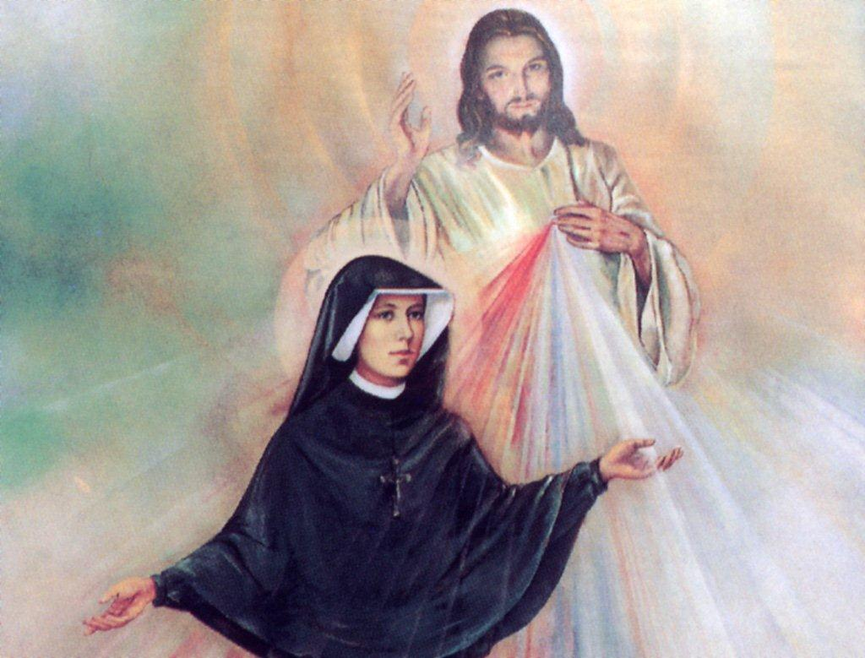

REFORMED CATHOLIC CHURCH
CARMELITE FRIARS OF THE DIVINE MERCY
“APOSTLES OF MERCY”

CONSTITUTION AND BYLAWS

2010
Revised May 14th, 2026

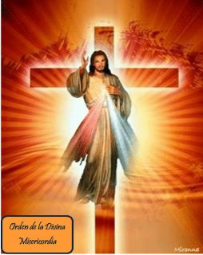
PART I:
Apostles of Mercy: Pilgrims of Silence…
called to be instruments of the merciful love of God

CHAPTER 1
THE GIFT AND THE MISSION OF THE ORDER

- Through Jesus Christ, Son of Father and ¨firstborn of all creation¨¹, we live in union with God and with our neighbors in a new way. And so, we share in the mission of the Incarnate Word in this world, and we form the Church, which is in Christ ¨as a sacrament-- a sign and instrument of communion with God, and of the unity of the whole human race¨.²

- Living in allegiance to Jesus Christ³ and embracing his Gospel as the supreme norm of our lives⁴, by the power of his Spirit who distributes his gifts to each according to his will, we seek to live together in mutual service of one another and of all people. In this way, we cooperate in God´s plan to gather all men and women into one Holy People.

- Among the gifts of the Holy Spirit is the evangelical life, which we profess as religious, called by Christ to live and to spread his transforming and liberating power, and even evangelical life itself, in a manner that is specific to us, effective, and contemporary. This life is characterized by an intense search for God, in total adherence to Christ, finding expression in fraternal life and apostolic zeal.

- Inherent in this vocation is the full acceptance of the conditions in which Christ sets for those who wish to follow him in this kind of life. It involves acceptance of God´s will, as sharing in Christ´s obedience. It also includes the life of poverty and community of goods, as an expression of our unity in Christ and of mutual gospel-inspired union with our brothers. Finally, it is consecrated chastity, as an expression of our love of God and or our brothers and sisters.

- We look upon our consecrated life above all as an invitation and a great gift from God, by which he consecrates us to himself, that we may serve our brothers and sisters following Christ´s example. This vocation perfects in us, through our shared brotherhood, the power, which is also charismatic, a gift of the Spirit, received at baptism and at confirmation, binding us in a special way to the Church and making us ready to serve God and humanity, to implant and strengthen the Kingdom of Christ in souls, and to spread it to the four corners to the earth.

- By faith we know that Jesus is the Son of God; the He came into the world to save us, teaching us through His example and His word the way to salvation and to Heaven.

- Jesus is the One Who with His life, passion and death taught us perfect abandonment to the Divine will of the Father.

- It is the fulfillment of the Lord � s will that brought about the Redemption, liberating us from the slavery of sin. Thus, Jesus is the Eternal Mercy of Father for fallen humanity.

- In this context, we the Apostles of the Divine Mercy of the Apostles of Mercy are engaged in a process of self-examination and seek to define the characteristics among the many charismas and vocations which give our religious family its identity within the Church.

- Our spirituality is characterized by three features: faith in Jesus; abandonment to the Father´s Will; and the adoration of and teaching concerning His Divine Mercy. All of this is to be lived under the protection and the example of the Blessed Virgin Mary, woman of faith and abandonment par excellence, and our Mother of Mercy.

- By faith we mean not only believing in God Almighty, but also going to the depth of authentic faith, which means believing God, who truly speaks to us through the Gospel and in various other ways. This act of believing God is more difficult, above all these times, which abound with information, scientific knowledge, and technology, but which are also affected by rationalism and plagued by doubt.

- Believing God also means trusting in the Holy Spirit, present and active today in His Church. This includes a prudent openness to the charisms that He may give, especially those given to the little and ignorant ones according to the world.

- St. Faustina is of special importance for our community. She received momentous revelations destined for today´s world to renew trust in the Gospel´s good news of God´s mercy. Our community is to be rooted in His mercy, striving to live and promote this message.

- The world desperately needs to know of the great mercy that God has for us sinners, so that all of us may turn to Him wholeheartedly with a firm hope in His love and His pardon. Hence, our constant prayer to Our Lord asking for mercy for ourselves and for the world; and asking that one day God may be more known and praised for this which has been His greatest attribute.

- St. Therese of Avila, doctor of the Church, also is of great importance for our community. The spirituality promoted by her: prayer´s life, silence, solitude, brotherhood, docility to the Lord will help us embrace the spirituality to be developed in our Order, based upon the principles promoted by St. Therese in the reform of her order.

- Abandonment: faith leads to abandonment to the Divine Will, which draws great blessings from Heaven. By abandonment, the soul places its poor and humble will in unison with the Will of God, who causes or permits the events for each soul, and Who draws good from evil itself.

- As humans enter a new period of its history, we seek to adapt our way of life to new conditions. We seek to understand the signs to the times and to examine them in the light of the Gospel, of our charisma, and of our spiritual heritage, so that we may incarnate this way of life in different cultures.

CHAPTER II
THE CHARISM OF THE ORDER

The contemplative dimension of our life

- ¨To live a life of allegiance to Jesus Christ and to serve him faithfully with a pure heart and a clear conscience¨, these words, inspired by St. Paul, are the basis for all the elements or our charisma; they are the foundation upon we are to construct our lives. To imitate Jesus, living with His grace an apprenticeship in this abandonment to the Will of God; to live by trust and faith in God´s eternal mercy, His first and greatest attribute, still too little known.

- As a contemplative community our principle means for realizing our project of life are:

Daily celebration of the Holy Sacrifice of the Eucharist.

- The daily offering of the Holy Eucharist is the prayer par excellence in which Jesus offers Himself to Father as an oblation for the whole humanity.
- It is the ¨source and summit¨ of our Christian life.
- We want to live the celebration of the Holy Eucharist with loving reverence for these ¨Sacred Mysteries¨.

The practice of continuous prayer.

- The practice of continuous prayer involves an effort towards the constant repetition of the Holy Name of Jesus throughout the different activities of each day.
- It permits us to discipline our mind to center our spirit and our life in the constant contemplation of God: striving towards a continuous and uninterrupted contemplation of the Person of Jesus.

Adoration of the Blessed Sacrament.

- The adoration of the Eucharist permits the Christian to draw graces from heaven both for himself and for suffering humanity.
- In this passive activity in which man is quiet and Gods acts, the Lord communicates His gifts and His graces through the prayer of the one who adores Him.
- We are simple instruments of the God of Mercy.
- Our apostolate and missionary spirit consist first in this (recalling that St. Therese of Lisieux was named patron of the missions without having left her convent at all).

Appropriate apostolic activities

  - Appropriate apostolic activities provide a means by which this contemplative spirit of personal communion with God may be shared with men and women of all ages--- children, youth and adults.
  - A primary example will be the House of Prayer and Encounter with Jesus.
    - This retreat house will guide a person into a fellowship with Jesus Christ through adoration of the Blessed Sacrament and through personal, individual prayer lived out in silence.
    - Silence is a privileged means by which we may listen to and experience He who speaks to and inspires our soul.
  - This mission of the spiritual works of mercy does not exclude the possibility that the Apostles of Mercy may be led to other types of activities.
  - It is important to us to guard and protect the contemplative charisma of the Reformed Carmelites of the Divine Mercy. Therefore, whichever activities are developed by the community, should be in harmony with this charisma.

- Contemplation also has a gospel and an ecclesial value. The practice of contemplation is not only the source of our spiritual life; it also determines the quality of our fraternal life and of our service amid the people of God.

- The values of contemplation –when lived faithfully amid the complex events of daily life—make our brotherhood a witness to the living and mysterious presence of God among his people. The search for the face of God, and openness to the gifts of the Spirit, make us more attentive to the signs of the times and more sensitive to the seeds of the Word in history, seeing and evaluating facts and events within the Church and within society.

- Through living like Christ, in solidarity with the events and the hopes of the human race, we will be able to make appropriate decisions to transform life, making it conform more closely to the will of the Father. Moreover, for the good of the Church, the contemplative dimension will encourage those who feel called to an eremitical life.

- Through our prayer life the brother of the Apostles of Mercy will be able to accompany all those persons who are in need to be accompanied; to be held by their hands and be delivered to our Lord. As Pilgrims of Silence, we are called to instill support to all those people who actually feel are being discriminated by our society due to their sexual orientation or any other situation that excludes them from different groups.

FRATERNITY

- A contemplative attitude toward the world around us allow us to discover the presence of God in the events of ordinary daily life and especially, to see him in our brothers and sisters. Thus, we are led to appreciate the mystery of those with whom we share our lives. Our project of life as members of the Apostles of Mercy requires us to be essentially ¨brothers¨ and remind us that the quality of interpersonal relationships within the community needs to be constantly developed and enhanced, following the inspiring example of the first community in Jerusalem.

- For us to be brothers means to grow in communion and in unity, overcoming privileges and distinctions, in a spirit of participation and co-responsibility, in sharing material possessions, a common program of life, and personal charismas, to be brothers also means to care for one another´s spiritual and psychological well-being, through walking in the way of dialogue and reconciliation. To be brothers means also to accept each one as they are.

- These fraternal values find expression and nourishment in the Word, in the Eucharist, and in prayer. Hearing, praying and living the Word—in silence--, in solitude and in community, especially in the form of Lectio Divina. In this way the brothers of our community will be led, day by day, to know and experience the mystery of Jesus Christ.

- Inspired the Spirit and rooted in Jesus Christ, abiding in him by day and by night, the brothers of the Apostles of Mercy will allow every choice and every action to be guided by his Word and by His Divine Mercy, inviting others to share in their experience of prayer.

Service among the people

- As a contemplative brotherhood, we seek the face of God also in the heart of the world. We believe that God has established his dwelling place among his people, and for this reason, our brotherhood knows itself to be a living part of the Church—an open fraternity, able to listen to the world it lives in, and willing to be questioned by it; ready both to meet life´s challenges and to give an authentic, evangelical response based on our own charisma.

- We will show solidarity and will be eager to collaborate with all who suffer, who hope, and who commit themselves to the search for the Kingdom of God; for all who feel discriminated and segregated from their families or communities due to their personal identity or due to their civil status.

- The community residence is where the community gathers and lives; it is to be a place of welcome and hospitality, so that people share in a common spirit, in fraternal reconciliation and in the experience of God lived in the community.

- Finally, this way of being ¨amid the people¨ is a sign and a prophetic witness of new relationships of fraternity and friendship among men and women everywhere. It is a prophetic message of justice and peace in society and amongst people.

- As an integral part of the Good News, this prophecy must be fulfilled through active commitment to the transformation of sinful systems and structures into grace-filled systems and structures. It is also an expression of the choice to share in the lives of the little ones of history, so that we may speak a word of hope, mercy and of salvation from their midst—more by our life than by our words. This option flows naturally from our profession of poverty, and is in keeping with our allegiance to Jesus Christ, lived out also through allegiance to the poor, the needy, the sick, the discriminated person (gays, lesbians, and divorcees), in whom the face of our Lord is reflected in a preferential way.

- Every day, if possible, the Apostles of the Divine Mercy are called, from solitude and from their apostolic work, to the Eucharist---source and culminations of their lives—so that, gathered together around the Lord´s table, they may be united, heart and soul, living true, fraternal koinonia in unselfishness, in mutual service, in faithfulness to a common goal and in a spirit of reconciliation inspired by Christ´s love and His Divine Mercy.

- All brothers of the Reformed Carmelites of the Divine Mercy, as a contemplative fraternity, will seek the face of God and will serve the Church in the world.

- The fraternity of the Apostles of Mercy will constitute different branches within itself: religious men (priests and Apostles); religious women; consecrated laymen; consecrated laywomen; and lay members. Members of this last branch, singles or married, will live their commitment in the world. Members of the other branches will live together in their respective communities or as directed by Father Prior.

- The men´s and women´s branches will have separate living areas and will preserve the due distance and distinction that prudence, respect and mutual charity require. Some of the activities will be realized in common, for example: participation in the Holy Eucharist; adoration of the Blessed Sacrament; and the organization of the retreat apostolate.

- This communion amongst the members of the Apostles of Mercy has its source in our communion with the Blessed Trinity, which also calls us to a deeper communion with all who dwell in His love:

  - With the local church and its pastor: in communion with and under the guidance of our Diocesan Bishop in the Reformed Catholic Church, we wish to offer our charisma as a spiritual resource at the service of the local Church.
  - With the saints in heaven: The Apostles of Mercy is a new order within the Reformed Catholic Church, born in this third millennium in the situation of today, in a missionary diocese. But this newness is rooted in the great tradition of holiness in the Church, supported and inspired by the founding Apostles who are rooted in the Teresian Tradition.
  - With the angels and archangels: In this great mission, conscious of our weakness, we sense a particular need to turn with confidence also to our beloved angels, especially: St. Michael, St. Gabriel and St. Raphael.
  - With our brothers and sisters in Purgatory: An important part of this mission of the Reformed Carmelites of the Divine Mercy, too easily forgotten, is to help those souls being purified.
  - With non-Catholic Christians, the un-churched and with all persons of good will: The mission of the Apostles of Mercy in enclosed within the Reformed Catholic Church, but far from excluding others, we want to be open to all with whom the Lord would like us to share this spirit.
  - With the discriminated persons of our society: the mission of the Apostles of Mercy is especially directed to the sick, elderly, divorced and homosexuals…we are called to help these brothers to find the merciful love of God.

PART II
A CALL TO LIVE THE DIVINE MERCY PROJECT OF LIFE…
A CONTEMPLATIVE BROTHERHOOD AMONGST THE PEOPLE
Apostles of Mercy
Living within the silence of God.

CHAPTER III
Life in the Community

- The Holy Trinity, source and model of the Church, is also the source and the model of our life as brothers.

- The Trinitarian communion (koinonia) of knowledge and love in which we share comes to us as gift and urges us to open ourselves to knowledge and love of God and of our neighbors. Thus, growth in knowledge and in love within each local community, open to the entire Order, to the Church and to the whole human race, manifests ever more perfectly this fundamental element as brothers of the Divine Mercy.

- Fraternal life modeled on the Jerusalem community is an incarnation of God´s gratuitous love, internalized through an ongoing process by which we empty ourselves of all egocentricity—which can affect groups as much as individuals—as we move towards authentic centering in God´s Mercy. In this way we express the charismatic and prophetic nature of the consecrated life, weaving harmoniously into the personal charisma of each member, in the service of the Church and of the world. We are therefore called to renew ourselves, as brothers in dialogue with one another, open to the signs of the times—and therefore to all people—welcoming those who are involved in our ministry, especially the young, the poor and the discriminated against. We are also open to developing new forms of community and new ministries, that may have a decisive impact on the Church and on society, inviting all people to conversion.

- Community life must tend towards deeper union, in mutual knowledge and love. To this end, our life in common has moments of intensity and importance:

  - In the shared participation in the Holy Eucharist, through which we become one body, and which is the source and the summit of our lives, and therefore the sacrament of brotherhood.
  - In the communal celebration of the Liturgy of the Hours.
  - In the prayerful listening to the Word.
  - In meetings to be held periodically, according to the Order Statutes, to discuss issues which concern the life and growth of the community.
  - In other community meetings, to be held periodically according to the Order Statues, where—in the spirit of dialogue and discernment—we study our Project of Life, the writings of our mystics, and the official documents of the Church and of the Order.
    - We examine our faithfulness to the charisma and to the mission of the Reformed Carmelites of the Divine Mercy.
    - We share our experiences.
    - We develop our aims for community life (community project).
    - We learn to read the signs of times.
    - We make pastoral choices in the context of the local and international Church.
    - In the common table and recreation together.
    - In common work, manual and others, whether within the community or elsewhere on behalf of the community.
    - In the sharing of joy, anxieties and friendships.

- All our activities outside the community house shall be closely related to our life within the community and shall form with it a seamless whole. It is the very purpose of houses of apostolic brotherhood to be present among the people: to be open and closely joined with them, stimulating a critical reflection on their human needs. In this way, our communities will be authentic expressions of faith, hope, abandonment and charity, and will become places conducive to full human development.

- By its very nature, community life must promote human, intellectual, spiritual and pastoral growth of all religious members, so that they may be fully integrated into the community and into its mission, according to personal qualities and aptitudes. Thus, the expression of unity is to be sought in organic diversity—not in shapeless community´s choices of activities. In some instances, experts and facilitators may be called upon to assist us in community dialogue. Moreover, communities shall ensure that no member is so overloaded with work—be it apostolic or other—that community life and religious exercises become impossible or too difficult.

- To promote the growth of the contemplative and fraternal dimensions of our lives, both excessive activity and undisciplined behavior should be avoided, and likewise any lifestyle which is contrary to the deepest aspirations of the consecrated and ordained life.

- As a religious family we are to be aware of the growing importance of worldwide communication in present-day society, and of the major technological innovations in this field. There is no doubt that the mass media can play an important role in evangelization; the abuse and manipulative use of the media, however, can endanger human dignity and freedom. Our communities should therefore evaluate the best ways to make use of the mass media, with a view both to safeguarding the contemplative and fraternal dimensions of our lives, and to increasing the effectiveness of our apostolate.

- Each community shall comprise itself with enough Apostles to create an appropriate environment in which a truly fraternal life can develop. In some instances, brothers will live out of the community house to be able to work in their professional labors or in their ministries. Their homes will be subrogated to the main Mission House.

- Any Apostle or priest who, for reasons of health, study, professional work, or apostolate, or for some other legitimate motive, must live outside his community house, shall be attached to a well-established community, whose members shall encourage a fraternal relationship, assisting him in his activities, and vice-versa. For his part, as far as he can, he shall visit the community on a regular basis and shall willingly take part in some of the community´s religious activities and meetings, to benefit more fully from the advantages of his brotherhood.

- Hospitality is a characteristic of fraternal life, and it is to be extended not only to the brothers within the Order and to members of their families, but also to others, insofar as possible.

- To ensure that the economic structure or our religious life does not resemble existing global systems of unjust inequality, fraternity within the Apostles of Mercy family should find expression in concern for and sharing with communities throughout the Order, in particular the poorer amongst them.

- It is necessary to foster attitudes of respect and gratitude towards the elderly who have spent their energies working for the Order and for the Church. The community shall welcome their contribution to its activities, according to their abilities, and shall avoid evaluating individuals based on such anti-evangelical criteria as efficiency and productivity.

- Communities shall welcome as a gift the presence of sick brothers, seeing in them the suffering Christ. Our brotherhood must be expressed in a very special way in the loving consideration with which we care for our sick or infirm brothers. Communities should ensure that these brothers lack nothing that might help them to regain their health; they shall be sent, if necessary, to clinics or places of health care, and shall have the support of every spiritual help.

- Praying for the dead ¨is a holy and pious thought¨. We shall therefore devoutly remember in the Lord our dead brothers, by offering Masses on their behalf and praying for them, so that we may remain in spiritual union with them.

- Daily conversion to the Gospel is essential if we are to remain faithful to our vocation to fraternal life. Religious communities must be seen in the Church as prayerful and in a constant process of conversion. We must seek concrete forms of conversion, above all through a constant discernment of life in the light of the Gospel, of the signs of the times, and the experience of the poor, the elderly and the sick; and through the faithful fulfillment of our ministries, taking into account the circumstances and traditions of the diocesan Church. Every community will decide appropriate ways to practice the spirit of penance. Provided they do not contradict the prescriptions of canon law or the College of Bishops norms concerning fast and abstinence.

- Our religious habit is a sign of consecration, and consists of a brown tunic, a brown scapular with capuche; a leather belt to be worn over the tunic and scapular. On more solemn occasions, a beige cloak shall be worn, which is shorter than the tunic and has a beige capuche of the same shape as the blue one. All Apostles, once invested with their habit in the novitiate, are to always use their habits. Wearing the habit inside and outside the house is a matter to be decided by every community according to their ministries. The Divine Mercy Cross will be embroidered over the front scapular.

- Wearing a habit by the religious member of our Order reminds him at all times of his vows and helps him to become a radical follower of Jesus Christ, allowing himself to forget about himself and keep in mind the Divine Mercy of our Lord.

CHAPTER IV
EVANGELICAL COUNSELS AND VOWS

- The essence and foundation of consecrated life is the radical following of Jesus Christ. The evangelical counsels of obedience, poverty and chastity, publicly professed in the Church, are a radical form of witness to the following of Christ. As we follow the obedient, poor and chaste Christ, we become less focused on ourselves, and we orient ourselves in history to the search for the Kingdom of God. Married brothers and/or sisters are to live chastity in their state of life.

- Our consecrated life, configured to the life of Christ by means of the three evangelical counsels taken on by the vows, and other evangelical values, is a gift from God. Its motivation is not that of the world, yet it places us in the world as witnesses to the value of life itself as a precious gift. This value, lived in the spirit of the beatitudes, transfigures the world according to the Father´s design.

- OBEDIENCE: hearing and discerning God´s plan

    - By means of religious obedience, genuinely observed in deeds, we surrender our will fully to God.
    - Jesus Christ is the source and the reason of our obedience. He lived his freedom not in self-sufficiency and personal autonomy, bit in obedience to the Father.
    - Christ´s obedience was not only a commitment to do his Father´s works, it was also a faithfulness to humanity and to the salvation of all.
    - Jesus obeyed because he loved his Father, and because he loved us.
    - Jesus was wholly of God, and wholly for people. The only purpose of his life was to bring about the Kingdom of God, and to this goal he remained faithful unto death.
    - The Spirit of Jesus lives in us; we are not under the law, but under grace. Allowing the Spirit to guide us, we shall be taught to discern the will of God, and we shall be led to the complete truth.
    - Today, for us, following Christ in his obedience means listening together to the word of God, received and lived in the Church; learning to read the signs of times to discern the will of God today, and fulfilling faithfully, day by day, whatever mission he entrusts to us. This involves a constant process of transformation to internalize the will of God.
    - We commit ourselves to obey God´s will not only as individuals, but also as a community. It is in community that together we seek to know the will of God. We engage in this search in a spirit of mutual discipleship and co-responsibility, as we listen to and fulfill the Word of God, read in the light of the signs of the times and in keeping with the charisma of the Order. In this way, we are brothers in obedience; side by side and together, we face the challenges of the Gospel and the coming of the Kingdom of God.
    - Father Prior, conscious of the presence of Christ and of his Gospel at the heart of the community, shall place himself at the service of God´s will and at the service of his brethren, guiding them to mature and be responsibly obedient to Christ, through dialogue and timely discernment, while remaining firm in his authority to decide and to command what must be done.
    - In the community, Father Prior must be a stimulus to live out our charisma; he must be a sign and a bond of unity. The brothers are to hold their Father Prior humbly in honor, thinking not so much of him as of Christ who placed him over them.

- POVERTY: sharing and solidarity

  - Jesus Christ the poor man, was born and lived in loneliness. During his life on earth, he chose to be deprived of all worldly riches, power and prestige. He took the form of a slave, becoming as human beings are, and identified with the little ones and with the poor. He shared all his life with his disciples; he shared his Father´s plans, his mission, and his prayer. In this way, he became not only their master, but their friend and brother. On the cross, in keeping with the Father´s plan, Jesus experienced absolute nakedness and radical poverty. From the cross he gave himself up completely, for the sake of humanity. Rich though he was, Jesus became poor for us, so that, through his poverty, we might be made rich.
  - As they followed Jesus, the poor man, the early Christian communities, inspired by fraternal communion (koinonia), lived and pursued a sharing of all materials and spiritual goods.
  - As we follow Jesus and take as our model the life of the primitive Church, we too wish to embrace willingly the gift of the evangelical counsel of poverty, by our vow to hold all things in common, and by declaring that no object belongs to any of us personally.
  - We believe that all we have is gift, and that all we have—all the spiritual, material, and cultural goods that are obtained by our work—must be freely returned, in whatever way can best serve the good of the Church and of our Order, for the human and social development of all.
  - In contemplation, we internalize the authentic attitude of poverty, which is a deep process of inner self-emptying through which we become less in control of our own activity and ideas, of our virtues and of our ambitions, as we open ourselves to God´s actions. In this way, we become truly poor as Christ as poor, even to the point of not owning the poverty we have chosen in this process by which God´s love empties us.
  - Those who freely chose poverty as our evangelical lifestyle feel called by the Gospel and by the Church to awaken people´s consciences to the problems of destitution, hunger and social injustice.
  - Solemnly professed religious shall have no personal material possessions; whatever they receive shall belong to the house, or to the Order, according to the Constitutions.
  - In our use of material goods, it is our responsibility before God to observe faithfully the poverty which we have freely professed, keeping in mind that we make the vow of poverty to live a simple life, individually and within our communities, avoiding whatever might offend the sensibilities of the poor.
  - Let us remember that in our time the best way to make manifest our vow of poverty is to faithfully fulfill the common law of work. Let us, therefore, embrace with enthusiasm the precept which invites us to work assiduously, for we know that by our toil we cooperate in God´s work of creation and, at the same time, develop our own personalities; by our active charity we assist our community, and all other; and we contribute to the good of the Order. Moreover, we perpetuate the dignity Jesus gave to work—for he never disdained manual work—and we follow the example of the Blessed Virgin Mary, whose life on earth was full of ordinary concerns and work.

- CHASTITY: celibate for the Kingdom of God

  - The God of the Kingdom and the Kingdom of God are the essential points of reference and the universal framework for our celibate lives, and for all Christian existence.
  - Only God´s love can call us decisively to religious chastity. This love demands a fraternal charity so powerful that it will lead religious to live more deeply with their fellow men and women in the heart of Christ. The gift of self, to God and to others, will then be the source of profound peace.
  - Jesus Christ, the chaste man, dedicated himself wholly to the cause of the Kingdom. He loved everyone, especially the little ones and the poor. His love was never possessive. It was liberating, totally dedicated to the service of his brothers and sisters.
  - As we follow Jesus in his chastity, our celibacy also takes on the quality of a full and a total love for God and for every human being. Aware of God´s love, which stands over every individual, we must continually be transformed by this disinterested and unconditional divine love.
  - Love lived out in celibacy has for us—as it had for Jesus—both mystical value and social or positive value: it is at the same time the undivided love of God—the only Absolute who gives meaning to our existence—and a preferential, gratuitous and liberating love for the humble and the poor, in order that the values of the Kingdom of God—equality, solidarity, and dignity of the human person—may take root and spread throughout the human community.
  - Married couples are not obliged to comply with the vow of chastity. Nevertheless, they can live act always with a pure heart and comply with the chastity vow.
  - The charisma of consecrated chastity is a gift from God, but we know that we carry this gift in earthen vessels, that is, in our weak and fragile humanity. For this reason, we feel the need to live according to values which promote a balanced and mature integration of our affectivity and our capacity for tenderness with evangelical attitudes, in a way that is coherent with our way of living. If our celibate life, chosen for the Kingdom, is to be a suitable vehicle for our maturity as human beings and for our growth in faith, we need to be instructed, first of all in authentic brotherly love; in communication and community dialogue; and in the ability to love others not possessively, but appreciating them as persons. We must learn also the meaning of gift, of gratuitous service, and of straightforwardness in friendships.
  - Finally, we must come to understand silence as attentiveness to the Word, and Christian asceticism as that which purifies our feelings and re-establishes our authentic relationships with others, sharing in the cross of Christ, who carried to the limit his selfless love for his Father and for his brothers and sisters.

CHAPTER V
PRAYER LIFE

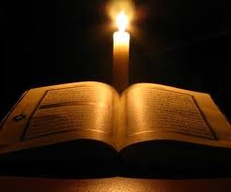

Prayer in General

- The Holy Trinity draws us into communion with themselves and with one another, in faith, in hope and in charity.

- These virtues are experienced, nourished and expressed in prayer, as we turn our attention to God, in adoration and in love, in obedient listening, in sincere contrition, and in hope-filled petition.

- Prayer is the fruit of the action of the Holy Spirit in us and in our lives. It is the Spirit who gives us words when we can find no words; who leads us to unity with the entire Church; who helps us to deepen our experience of intimacy with God.

- Seeking inspiration in the authentic sources of Christian spirituality, we bring together our sense of God and our human experience. When we pray, we keep in mind the needs and the concerns of the world we live in, together with an awareness of our own calling to serve all the members of the Church.

- Prayer can assume a variety of forms, according to the needs of the community and of everyone; it is nourished by the constant search for God, supported by Lectio Divina, by study, by meditation and by the sacraments. This constant search for God must be the foundation and the highest expression of community life.

- The silence of solitude which individuals and communities must cultivate makes us docile to the voice of the Holy Spirit. In all the houses of the Order we must therefore create and foster an atmosphere of silence, recollection and solitude. This will enable us to engage more easily in personal prayer, and to make our study and other activities more fruitful.

Liturgical Prayer

- As in the primitive Church, as religious men we are called to celebrate together the Eucharist and the Liturgy of the Hours.

- Liturgical prayer is the highest form of communal encounter with God and brings about what it celebrates.

- Personal prayer is intimately linked with liturgical prayer; one flows from the other.

- The daily celebration of the Eucharistic Sacrifice is to be the center and the culmination of the life of the community. It is our way of expressing our desire to go with Christ to the Father. We offer him in total sacrifice our daily lives intimately united with Christ´s paschal mystery, so that we may be perfected daily in union with God and with one another, through Christ the Mediator, and so that God may finally become all in all.

- In the celebration of the Eucharist, as we share in the table of the Lord and participate in the effects of Christ´s sacrifice, community is built, and our unity with the entire family of believers is established and made manifest.

- The sacred liturgy unites us with the apostolic witness and with the faith of the entire Church.

- The public prayer of the Church is the manifestation of our participation in the Church at prayer, which, together with Christ, is ceaselessly engaged in praising the Lord and interceding for the salvation of the entire world through his Divine Mercy.

- The Liturgy of the Hours extends praise and prayer to the different hours of the day, making present the mysteries of salvation, the prayers of intercession, and the foretaste of heavenly glory which are offered to us in the Eucharistic Mystery.

- Together with the Eucharistic celebration, the Liturgy of the Hours unfolds for us continuously throughout the liturgical year the mysteries of the redemption accomplished for us by Our Lord Jesus Christ, so that we may encounter them and thus be filled with the grace of salvation.

- The Liturgy of the Hours is to be celebrated in common; provision should therefore be made to allow all members to participate. Where special difficulties exist in a particular community, at least Morning and Evening Prayer shall be recited in common every day. Those parts which, for whatever reason, are not recited in common, shall be said in private.

- In places where we engage in pastoral work, it is fitting that we celebrate some part of the Liturgy of the Hours with the faithful.

- We shall confess our sins frequently to the Church in the sacrament of reconciliation, also celebrating it communally in keeping with the practices of local Churches. We shall thus obtain forgiveness through God´s mercy for the offenses we have committed against him and shall at the same time be reconciled with the Church.

- Every member of the Order can confess to any priest in full communion with the Church, by virtue of these bylaws.

Personal Prayer

- Christians are certainly called to pray together; however, they must also draw apart and pray to God in secret. We must make special efforts to help one another to seek God through prayer that is intimately linked with ordinary daily life.

- Spiritual formation shall be closely linked with doctrinal and pastoral formation and shall be presented in such a way that it may teach us to live intimate communion and friendship with the Father, through his Son Jesus Christ, and in the Holy Spirit.

- Our entire lives must be imbued with a deep religious sense, so that we may view the events of our own lives and of the world around us in the light of God. Thus, our whole life must be deeply contemplative, so that we may come to see all that happens as if with the eyes of God.

- Contemplation is truly a gift from God. God takes the initiative; he reaches out to us and fills us ever more deeply with his life and his love; we respond to him by allowing him to be God in our lives.

- Contemplation is an attitude of openness to God, whose presence we discover everywhere. In this way we follow the examples of the prophet Elijah, who ceaselessly looked for God, and of Mary, who pondered all things in her heart.

- Silent prayer is of great assistance in developing a spirit of contemplation; we should therefore practice it daily for an appropriate length of time.

- A life of prayer also requires us to examine our way of life in the light of the Gospel, so that prayer may influence both our personal lives and the lives of our communities. (1 Kgs 17:1, 15; 18:19, 21; 2 Kgs 1:2) (Lk 2: 19, 51)

- Lectio Divina is an authentic source of Christian spirituality recommended to all our religious members. We therefore practice it every day, so that we may develop a deep and genuine love for it, and so that we may grow in surpassing knowledge of Christ.

- It is suggested that Lectio Divina be practiced communally on a regular basis, so that the brethren may share their experience of God and respond together to the challenges of the Word.

- The reading of spiritual books, especially the Diary of St. Faustina Kowalska, the complete works of St. Therese of Avila and of St. John of the Cross, are highly recommended.

- Retreats and days of recollection shall be decided by communities, according to the guidelines given by Father Prior.

- The one indispensable thing is that prayer permeates our lives, so that, in faith, hope, abandonment, and charity, we may be able to glorify the name of Father on earth, in union with Jesus Christ.

- ¨We must pray at all times¨.

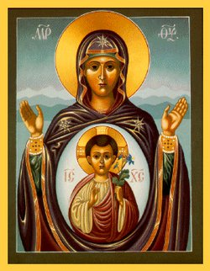

Veneration to our Blessed Virgin Mary and to the Saints

- During her life on earth, the Blessed Virgin Mary showed herself to be the perfect image for the disciple of Christ. For this reason, in her apostolic mission the Church follows the example of the Virgin Mother of God—the perfect model of the following of Christ—especially in her commitment to our redemption, which Mary actively participated in from her ¨Fiat¨ to the Incarnation, to her presence at the foot of the Cross, and in her solidarity with the first Christian community gathered in prayer.

- Veneration of the Blessed Virgin Mary of Mount Carmel, and the obligation to spread this devotion, are intrinsic parts of the Order´s mission within the Church. This will lead to celebrate the mysteries of Christ with the same dispositions and attitudes with which the Virgin contemplated her Son in Bethlehem, in Nazareth, and in his self-emptying, and exulted together with all her new children at his Resurrection.

- We must express our devotion to the Blessed Virgin Mary Mother of Mount Carmel by celebrating commemoration every year with special solemnity.

- All other Marian feasts included in the liturgical calendar shall be celebrated solemnly and, when liturgical laws permit, the Votive Mass of the Blessed Virgin and the Office of Mary are recommended on Saturdays.

- During the liturgical year, the Church celebrates the paschal mystery of Christ realized in the saints. We are called to celebrate St. Faustina, St. Therese of Avila, St. Therese of Lisieux and St. John of the Cross with devotion, finding in them the most intense and authentic expression of the charisma and spirituality of our Order.

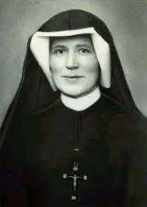
CHAPTER VI: OUR APOSTOLIC MISSION: General Considerations

- The mission of our Order shares in the mission of Jesus, who was sent to proclaim the Good News of the Kingdom of God and to bring the total liberation of humanity from all sin and oppression through his Divine Mercy.

- As missionaries we must fulfill our mission among the people first and foremost through the richness of our contemplative life.

- Inspired by the fundamental directions of our charisma and by present-day ecclesial and social contexts, the following guidelines are offered for the discernment of our apostolic mission:

    - A life of brotherhood and prayer amid the people.
    - A response to the needs of the diocesan and universal Church.
    - A preferential service to the poor and the marginalized.
    - A special attention to issues concerning homosexuals and women.
    - A commitment to justice and peace;
    - A care for those who show an interest in the spirituality started by St. Faustina.

CHAPTER VII
OUR APOSTOLIC MISSION IN THE LOCAL CHURCH

- While preserving its universal character, we shall endeavor to be fully involved in the life of our Church. This implies close cooperation with the various elements of the Church, offering the contribution of our charisma to the task of evangelization by fostering deep grasp of the contemplative dimension of life, of fraternity, and concrete commitment to justice.

- We shall encourage lay people to develop their own gifts and charismas, so they may be involved in the mission of the Church. Let our mission, inspired by the criteria set forth in previous articles, be one that both evangelizes and is evangelized within the Church—a mission that is particularly concerned for those who have lost their way and must be brought in reconciliation with the Mercy of our Lord.

- We also accomplish our mission through the work we do in our local communities and parishes in response to the pastoral needs of the areas where our communities are located.

- Those who are engaged in any type of ministry within a diocese are subject to the jurisdiction of the bishop, in keeping with canon law, in all matters pertaining to the faithful execution of their pastoral duties.

- The mission—in other words, the task of announcing the Gospel in places where it is not known—is one of the fundamental activities of the Church, for the Church is missionary by its very nature.

- The main agent of the mission is the Holy Spirit, who inspires communities to appoint members to this task. It is the Spirit who gives the missionary charisma to those who are sent. In this work the Order recognizes immense opportunities in such areas as charity, evangelical proclamation, Christian education, culture, solidarity with the poor, the marginalized and discriminated, and the oppressed.

- All our communities shall support this essential task with their prayers and by encouraging the faithful to become personally involved and, according to their circumstances, to provide material help.

- Missionary work requires a specific spirituality and a process of inculturation; and we are confident therefore, that the mission will reveal the heart of the charisma of our Order in a new way for the good of the Reformed Catholic Church and of the Order, in general.

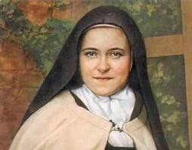

CHAPTER VIII: OUR APOSTOLIC MISSION AND THE PROMOTION OF JUSTICE AND PEACE THROUGHOUT THE WORLD

- Christ did not bring about the salvation of humanity as an outsider or as a stranger to the history of the world. On the contrary, he identified both with his people and with the whole human race. Those who claim to be followers of Christ must heed his call, especially when he says:

    - I was hungry and you gave me something to eat.
    - I was thirsty and you gave me to drink.
    - I was a stranger, and you welcome me.
    - I was naked and you clothed me.
    - I was sick and you visited me.
    - I was in prison, and you came to me.

- We live in a world full of injustice and disquiet. It is our duty to contribute to the search for an understanding of the causes of these evils; to be in solidarity with the sufferings of those who are marginalized; to share in their struggle for justice and peace; and to fight for their total liberation, helping them to fulfill their desire for a decent life.

- The poor, the little ones, constitute the vast majority of the world population. Their complex problems are linked and are mostly caused by current international relations and, more directly, by the economic and political systems which govern our world today. We cannot turn a deaf ear to the cry of the oppressed who plead for justice.

- We must hear and interpret the perspective of the poor—of those who are oppressed by the economic and political systems which today govern humanity. There are many problems, and we must set Father Priorities in responding to them. In this way, we shall rediscover the Gospel as good news, and Jesus Christ as the liberator from all forms of oppression.

- Social reality challenges us today. Attentive to the cry of the poor, and faithful to the Gospel, we must take our stand with them, making an option for the ¨little ones¨.

- We are called to walk with the ¨little ones¨, understanding not only the poor but all those people who are un-churched, who are abandoned, oppressed and marginalized by our society.

PART III
THE FORMATION PROCESS

CHAPTER IX
Apostles of Mercy: the process of formation

- Formation is a specific process through which a person learns to identify fully with the order ideal, which consists in contemplative fraternity lived amid the people while promoting the devotion to the Divine Mercy of Jesus.

- We are to learn to be more authentic disciples of Jesus Christ through their formation, participating in the offering he makes of himself to the Father, and sharing fully his mission for the good of humanity, in keeping with the specific charisma of the Reformed Carmelites of the Divine Mercy.

- We are called to maturity in Jesus Christ by virtue of baptism and confirmation and are therefore engaged in a continual process of conversion of heart and spiritual transformation and oblation.

- This is a life-long process which brings them into ever deeper communion with Jesus Christ our brother, in a spirit of solidarity and interdependence with all those in need of liberation and with the whole of creation which awaits His redemption and Divine Mercy.

- Our communities are to develop a lifestyle which will show this conversion and continual development of life in Christ, expressed in a spirit of thanksgiving for the vocation they have received. In this way their very existence will evangelize, attracting and inviting new vocations.

- The following guidelines are offered for candidates in initial formation. They reflect the process of formation in which we are engaged. The relationship between professed religious and new candidates should be based on interaction and openness to the promptings of the Holy Spirit.

- Committed members are to personify what the Order demands and the living charism that we are establishing; new candidates challenge and stimulate us through the personal gifts they have received from the Holy Spirit, thereby enriching and renewing our religious life.

CHAPTER X
The Ministry of Formation

- The process of formation in its various stages shall be entrusted to formatters who are mature, both in human experience and in the consecrated life, and capable of providing guidance and of accompanying the candidates on their journey.

- Father Prior shall appoint suitable formatters, trained specifically in the work they are to do; they shall not hesitate to exempt these formatters from their duties which may appear more important, but which cannot be compared with that of formation. In view of the importance and the heavy responsibilities attached to the role of formatter, those who engage in this task are to receive support and consideration, and special attention is to be paid to their general state of health.

- The general direction and guidance of all that pertains to formation is the prerogative of Father Prior General or his delegate for the Order as a whole.

- The primary responsibility for formation rests with the candidates themselves. They share this responsibility with their formatters, with the community in which they receive their formation, and with the major superior and his delegate.

- Norms and procedures pertaining to the formation of new candidates must include these criteria: personal talents and aspirations, the demands of communal living, and the concrete requirements of the Church. The norms for formation must also keep in mind the Order charisma and spirituality, the present Bylaws and other official documents of the Order.

CHAPTER XI
The Ministry of Vocations

- The vocation to the consecrated life is a gift of God, but this gift is to be meditated carefully. The attitude of individuals and of communities within the Order helps in discerning such vocations. Nothing promotes vocations more effectively than the enthusiasm of the religious (priests and Apostles all), which will reflect their pride in being members of the Order. This is expressed in their love for the Word of God, for the celebration of the liturgy, for community living, for being among the people in service and in ministry, and in the interest, they take in promoting Order activities and publications.

- Father Prior General will appoint a brother responsible for promoting vocations. His tasks will be:

  - To stimulate communities, encouraging members to become involved in the ministry of vocations and among the young, although our Order is open to mature men to enter.
  - To promote and coordinate vocation initiatives.
  - To discern signs of a vocation in candidates.
  - To accompany candidates as their vocation develops.

CHAPTER XII
The stages of Formation

- While formation is a life-long process, it has specific and progressive moments and stages:

  - Initial Formation:
    - Pre-Novitiate
    - Novitiate
    - Period of fist profession
  - Formation for various ministries begins during initial formation and continues after solemn profession
  - Ongoing Formation is a life-long process.
  - Initial Formation and Ongoing Formation must be understood as stages in one continuing process, each with its own specific goals.

- The pre-novitiate

    - Pre-Novitiate: duration of this formation stage will last between six and twelve months. A candidate will be suitable for the Novitiate when he has reached an awareness of being called by God and have been judged suitable by his superiors.
    - The goal of the pre-novitiate is to help candidates to know themselves better and understand their deeper vocational motives, to nourish their strength in responding to that call, and to provide them with the opportunity to experience God´s call in a climate of freedom and objectivity.
    - The right to admit to the pre-novitiate belongs to Father Prior, after hearing the views of those in charge of the pre-novitiate.
    - Candidates shall be admitted to the novitiate in accordance with the norms established by the Order. Normally the pre-novitiate stage will last between six to twelve months.

- The Novitiate

    - The Novitiate is a time of initiation in the religious life. During this stage, candidates shall experience our way of life to learn whether they are suited to it.
    - At the moment of vestition of the habit, the new novice will be granted a religious name, which he will use from that moment on (for religious purposes).
    - Novices must come to know and live the following of Christ, poor, chaste and obedient, within the framework established in the Apostles of Mercy charism.
    - Preferably, the novitiate shall take place in a house designated for this purpose by the Order.
    - Before entering the Novitiate, candidates shall make a retreat—in silence—for a period of at least seven (7) full days.
    - Candidates can be validly admitted to the novitiate only after their eighteenth birthday.

    - The novitiate begins with the rite of acceptance to the novitiate according to our Order´s ritual, by which the candidate is invested with the habit.
    - The whole community in which the novice resides is jointly responsible for his formation. However, guidance and direction of the candidate´s formation are to be entrusted to one specific religious who shall possess the appropriate gifts and a discerning judgment of modern culture which will enable him to prepare the candidate for life within the Order.
    - The program of the novitiate shall follow the guidelines established by the Order.
    - Ordinary studies shall be suspended for the duration of the novitiate. However, Father Prior may allow, or prescribe, courses in subjects which may help to complete the formation of the novice.
    - To complete the novice´s formation, Father Prior may allow the novices to undertake for one or more periods of time for some sort of apostolic activity, consonant with the nature of our Order, outside the novitiate house.
    - The time allocated to apostolic activity outside the novitiate house may be divided into several periods. Such apostolic activity shall not begin before the novice has spent at least three months in the novitiate house.
    - An absence from the Novitiate house for a period larger than three months, whether consecutive or interrupted, shall invalidate the novitiate, which shall then have to be repeated.
    - If a religious member who leaves the Order either at the end of this novitiate or after his profession wishes to be re-admitted, Father Prior, with the consent of his Council, may re-admit him. Father Prior is not obliged to require the candidate to repeat his novitiate; however, he shall impose a probation period, after which the candidate can be admitted taking vows. Father Prior should also determine the duration of temporary vows before solemn profession.
    - Novices enjoy all the spiritual benefits granted to the Order. The norms are to be observed with respect to the novice´s material goods.
    - Novitiate will last a period of twelve months (no more than two years). Nevertheless, Father Prior may deem necessary for a candidate to stay more time in the novitiate stage until the desired formation is covered satisfactorily.

- The Period of Simple Profession

  - At the end of the novitiate, candidates who are suitable and who freely ask to make profession shall do so. This profession marks the beginning of consecrated life. From this moment on, the newly professed member can add to his religious name the letters: RCDM.
  - Formation, however, must continue. Each stage must flow from the previous one in a systematic and balanced way. During this period, it is important that candidates deepen and consolidate their religious consecration to reach a final decision maturely.
  - Professional and technical training for various ministries should also take place at this time. Candidates must integrate their academic work and apostolic activities with a life of prayer and brotherhood.

  - At the end of the Novitiate, it is the prerogative of Father Prior, with the consent of his Council, to admit to temporary profession those candidates who have been found suitable. Father Prior has the right to receive first profession and renewal of vows.
  - For a valid reason, Father Prior may allow the first profession to be anticipated by a period not exceeding 15 days. Similarly, for a valid reason, he may permit first profession to be made outside of the novitiate house.
  - Father Prior may allow first profession to occur in Articulis Mortis in case the novice is in danger of his life. In case the novice recuperates his health, the novitiate formation will continue, and the novice will formally profess at the time it was originally contemplated.
  - Temporary profession should be made for a period of three years.
  - If appropriate, this period can be extended to up to six years, during which the candidate shall renew his temporary vows. In special cases, however, the major superior may grant a further extension of the period of temporary profession, but this shall not exceed three years.

- The Solemn Profession

  - Solemn profession shall be preceded by approximately one month of spiritual preparation.
  - Candidates shall spend this month in prayer and recollection, reflecting and meditating on the importance of this decisive and crucial act by which religious consecrate themselves forever to God.
  - For a solemn profession to be valid, the following conditions must be met:

  - The candidate must have reached the minimum age of 25 years old.
  - The candidate must have completed at least three years of temporary profession; for a valid reason, Father Prior may permit a solemn profession to be anticipated, but by no more than three months;
  - Father Prior shall admit candidates to profession, with a deliberative vote of his council.
  - Through solemn profession, candidates are definitively incardinated into the Order, with all the rights and obligations that this implies.
  - With respect to the material possessions of the professed, the norms laid down in our bylaws are to be observed.

- Formation for various ministries

  - The various ministries in which our brothers engage in the Order, each according to his personal vocation, grow out of the strength of the brotherhood, and at the same time bear witness to that brotherhood among the faithful.
  - In addition to our religious formation, our religious must receive an appropriate human, professional, scientific and technical education, according to their legitimate desires and capabilities, and in keeping with the needs and plans of the Order, so that they may fulfill their tasks with real competence, for the good of the people of God.
  - Religious who do not feel called to Holy Orders ordination shall be encouraged to engage in academic work, possibly leading to a higher degree, to be able to meet the needs of the people they serve.
  - It is the function of those who have received priestly ordination to cooperate with their Bishop; to spread the Word of God; to administer the sacraments; to provide leadership in the community; and to be Christ´s instruments in forming the people of God and in building the Gospel community. It follows that those of our religious who wish to receive Holy Orders should prepare themselves appropriately, completing their studies and their spiritual and pastoral training, in accordance with the norms established by the Vocation´s Office of the Reformed Catholic Church.
  - Solemn profession must precede reception of the Diaconate.

- Ongoing Formation

  - Ongoing formation is a response to the call of God, who calls each of his own at every moment and in new situations.
  - The grace of a vocation is seed which constantly grows and develops; to follow Christ is to undertake an ongoing journey. Hence, formation is never finished; and it requires us to be particularly attentive to the signs of the Spirit in our times, allowing ourselves to grow in awareness and in sensitivity, so that we may offer suitable responses to the problems of our contemporaries.
  - We are each responsible for our ongoing formation—for making space in our lives for a sense of the living God, to accomplish our ministry following Christ in a way that is ever more profound and contemporary.
  - Father Prior shall provide adequate means for ongoing spiritual, theological, doctrinal and professional formation.

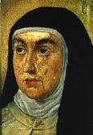

PART IV
GOVERNMENT

CHAPTER XIII
The Basic Structure of the Order and the law of order

- The Apostles of Mercy is included among the clerical institutes of the Divine Mercy Apostolic Catholic.

- The Apostles of Mercy is composed of Apostles who profess the three solemn vows of obedience, poverty and chastity, and who share a common purpose: to live the consecrated life according to the spirit and charisma of the Order.

- Members are incorporated first into the Order as a whole. Membership is received through temporary profession but only becomes final when members make their solemn profession, having completed the period of preparation.

- By virtue of profession, all the Apostles are equal with respect to rights and religious obligations, except for rights or obligations pertaining to specific offices or ministries.

- If the number of religious should increase over time, Father Prior, with the consent of his Council and observing due process of law, may provide for the erection of another house.

- A house is canonically erected by means of a decree, issued by Father Prior, with the consent of his Council, after obtaining written consent and decree from the Presiding Bishop of the Reformed Catholic Church.

- The consent of the Presiding Bishop is required to reassign a house, which had already been canonically erected, to apostolic works other than those for which it was originally established, except where changes concern only internal structure or religious discipline.

- Once the Order has a minimum of six solemnly professed Apostles, it will be able to conduct its first Chapter to elect Father Prior and his Council.

- In addition to the universal law of the Church, our Order is founded on its Rule, Constitution, Bylaws and General Codes.

- The Constitution contain fundamental laws which are necessary to govern the lives of all the Apostles, wherever they may be, in accordance with this Constitution.

- All the Apostles of the Divine Mercy will undertake to observe the laws contained in these Constitutions, knowing that it will be difficult to attain our goals and fraternal communion and evangelical perfection according to the charisma to the Order if we do not comply faithfully with these norms.

- It is the prerogative of the Chapter to approve, amend, appeal, repeal, or revoke the Constitution.

- It is the prerogative of the Chapter, and outside the Chapter, of Father Prior, with the consent of his Council, to approve, amend, repeal or revoke other general codes.

- Authentic interpretations of the Constitution and of other general codes of law pertain to the Chapter. In accordance with canon law, outside the Chapter, interpretations are given by Father Prior, with the consent of his Council; however, such interpretations are only valid for the specific cases for which they are given, and they cease to be valid with the following General Chapter, unless they are confirmed by the same Chapter.

- Other bodies within the Order, whatever their denomination, shall have their own Statutes, designed to meet local needs; such Statutes shall not contradict superior codes of laws.

- All Statutes must be approved by Father Prior, with the consent of his Council.

- Father Prior, with the consent of his Council, may issue decrees for the entire Order; however, such decrees lose all validity if they are not confirmed by the following General Chapter.

- Father Prior, with the consent of his respective Council, may issue decrees, provided they do not contradict a superior code of law.

- In matters pertaining to discipline, Father Prior, after hearing his Council, may exempt individual Apostles within the entire Order from the Constitutions and from other laws in the Order, for a just and reasonable cause.

- For a just and reasonable cause, Father Prior, after hearing his Council, may exempt his Apostles, wherever they may be, from disciplinary norms issued by the Order, except for those norms which are explicitly excluded; in special cases, he may even grant an habitual dispensation.

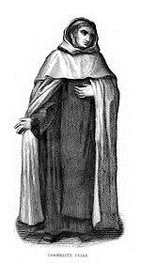

CHAPTER XIV
Active and Passive Voice

- All solemnly professed religious have the right to active (voting right) and passive voice (participating voice) in their community, except where the nature of the case or the present Constitutions clearly indicates otherwise.

- Members who have not yet made their solemn vows shall have neither active nor passive voice, even though they belong to the community.

- Father Prior has voice in the entire Order.

- Except for acquired rights, precedence among the brethren shall be as follows:
    - Father Prior in the whole Order.
    - The Vice Father Prior in the whole Order.
    - The members of the Council in the whole Order.

- After Father Prior and the Vice Father Prior, the members of the Council have precedence among themselves according to the date of their first profession; if they made their first profession on the same day, precedence shall be determined by date of birth.

- Except where Monastery Statutes provide otherwise, precedence among all the other members of the Order is determined by the date of first profession; and among those who made their first profession on the same day, precedence is determined by age.

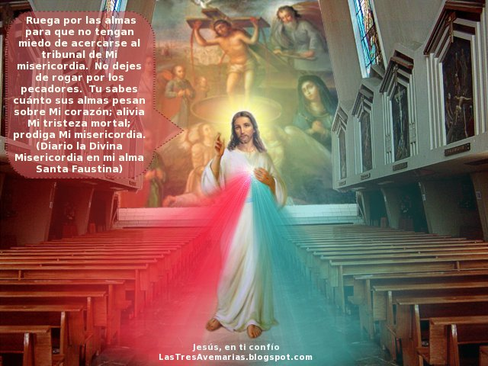

CHAPTER XV
Authority within the Order—Offices in General

- The Unity of the Order is founded on charity and on harmonious cooperation in the fulfillment of the ideal which we have set for ourselves. This unity is consolidated by authority, which stimulates us both to set our goals ever higher and to put in to practice the norms issued by the Church for all religious and the decisions made collegially ¨with the consent of the brethren¨.

- The brethren are fundamentally equal with respect to rights and obligations. However, in order that ¨those things that need to be done may ¨be well ordered¨, they choose among themselves some whose task it is to ensure the common good, as defined by Constitutions; to foster community life and apostolic work; and to channel the strengths of all the members so that they may converge into unity, in keeping with the provisions of these Constitutions and with those of individual communities.

- The religious who has the authority to govern the community is officially known as Father Prior—Father Prior General for the entire Order, in case more than one house is founded.

  - Father Prior is the sign of unity within the community which he is appointed to serve; or to the entire Order in case of appointing Father Prior General.
  - He becomes a model, in words and in deeds, for the group which is entrusted to him; as such, he shall be at hand to provide assistance to each and every religious; to foster community life; to care for all; and especially for the sick and the old; to supervise communal activities and initiatives so that these may become means by which the brethren can authentically live in allegiance to Jesus Christ, and serve Him faithfully with a pure heart and a clear conscience.
  - The superiors and the chapters of the Order enjoy both internal and external jurisdiction.
  - Father Prior has ordinary power over every Apostle, and over the houses. He exercises his authority on his own or with his Council, in keeping with canon law and with the law of the Order.
  - Father Prior governs the house with ordinary power, on his own or with the local Chapter in keeping with canon law and with the law of the Order.
    - When the law requires the consent of the Council, Father Prior acts invalidly when they go against the vote of their respective council.
    - When all that is required is consultation, Father Prior´s action will be valid if he has asked for the views of his Council of house Chapter. He is not obliged to follow their advice, if in conscience he feels that he must act otherwise. However, Father Prior should hold their opinion in high regard, if it is given unanimously by the Council members, and he shall not reject it without a reason which in his opinion is more valid. In urgent cases, the opinion of Council members may be sought individually, by letter or by any other means of communication.

- Only the Chapter can issue laws for the entire Order. Father Prior, assisted by his Council, has an obligation to ensure, in the first place, that existing regulations are implemented. They may also issue decrees according to their competence, provided these do not contradict the Constitutions.

- The Judicial power within the Order belongs to the Chapter.
    - The Chapter exercises this power through judges elected by the solemnly professed members of the same house; these judges pass sentence and issue decrees on behalf of the Chapter.

CHAPTER XVI
Chapters and other Collegial Acts

- Community Chapters and other collegial gatherings of the brethren are necessary to foster spiritual and apostolic life, updating them continuously in response to the demands of our time; strengthening brotherly love; and to examine and resolve common problems in the Order, and in each house, in a spirit of cooperation.

- Solemnly professed members of the Order shall attend meetings and other collegial meetings, to promote the common good.

- No one who is not a solemnly professed member of the Order shall be allowed to vote. Should such a person cast a vote, all the acts of the meeting shall automatically become null and void.

- Solemnly professed members and others whose consent or advice is required, shall express their views with respect, fidelity and sincerity.

- During elections, and in votes concerning individuals, voting shall be by secret ballot, and any form of acclamation is excluded.

- In other business to be dealt with collegially, voting need not to be secret, provided there is no objection from any of the members.

- Offices:

  - Offices and positions within the Order are conferred by a duly confirmed election; by postulations made in accordance with the law and approved by Father Prior with the consent of his Council; or by appointments, following appropriate consultations.
  - All offices shall be conferred in accordance with the law of the Order.
  - At the opening of a Community Chapter, all offices which are to be conferred during the Chapter become immediately vacant; however, outgoing officials continue to exercise their functions until the newly appointed take up office.
  - No member of the Order shall accept an office or function outside the Order without the permission of his Father Prior.
  - Appointments must be made in the spirit of fraternal dialogue.
  - All who have the right to vote must be summoned for elections.

  - Voting by proxy is not permitted.
  - Any one individual may cast only one vote, even if he has the right to vote on several grounds.
  - To be considered elected to a specific position, an absolute majority of the votes of those present shall be considered. If the first two ballots prove indecisive, voting shall be between the two candidates who have received the highest number of votes. The two candidates have no active voice in this ballot, and the one who receives the greater number of votes shall be considered elected. If in the third ballot, both candidates receive the same number of votes, the one who is senior by first profession shall be considered elected; or if both were professed on the same day, the one who is senior by age.
  - The person who has been elected shall be notified immediately of his election. If the person elected does not accept the appointment, he loses all rights deriving from it as soon as the president receives his refusal.
  - No confirmation is required for the election of Father Prior or of the members of his Council.

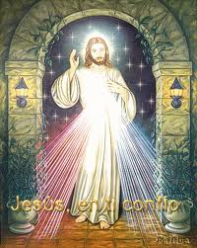

CHAPTER XVII
General Government

- The General Chapter is the supreme authority of the Order.

  - It is also the principal sign of the unity of our Order, in all its diversity.
  - It is the fraternal gathering in which we reflect together, in community, to strengthen our faithfulness to the Gospel and to our charisma, and our sensitivity to the needs of time and place
  - By means of the Chapter, the entire Order, allowing itself to be guided by the Holy Spirit, seeks to know the will of God at a particular moment in history, so that we may best serve the Church.
  - The Chapter is to be celebrated every three years, although Father Prior can call members to ordinary meetings as deemed necessary.
  - Father Prior, with the consent of his Council, may convene an extraordinary Chapter.
  - The members of the Chapter are the following:
    - Father Prior.
    - The Vice Father Prior.
    - The members of the Council.
    - All solemnly professed community members

- It is the responsibility of the Chapter:

  - To approve amendments to the Constitution and other general codes of the Order´s law for the Order in general; to foster spiritual and apostolic vitality; to draw up and communicate to the Council guidelines and criteria to be used by the Council in the government of the Order during the following six years; to adapt laws for the needs of time through an appropriate updating.
  - To elect Father Prior and the members of the Council.
  - To define the means and channels through which the life of the Order may radiate, in fraternal communication, to all the members.
  - To decide on any other matters which the Chapter may consider appropriate.

- Father Prior (General):

  - The one who is chosen to be Father Prior shall be distinguished for such natural gifts and virtues, such experience and wisdom, as qualifying him to take in hand the direction of the Order, worthily and effectively, according to the needs of the time.
  - It is his task to ensure effectively the common good of the whole Order; to work strenuously so that the authentic spirit of the Divine Mercy, especially with respect to the life of prayer, may be truly present in all members, and increase day by day; to promote tirelessly the growth and development of the Order and the apostolic and academic vitality of the religious members.
  - Father Prior should be elected for a three-year term, at the end of which he may be re-elected to the same office.
  - The Founding Father Prior once incardinated by the Metropolitan Archbishop and ratified in his position by the Presiding Bishop of the Reformed Catholic Church—USA—will be in office until six solemnly professed members of the community can carry out their first Chapter.
  - To be validly elected to the office of Father Prior, a candidate must be solemn professed member of the Order; he must be at least thirty-five years of age.
  - Father Prior has the authority:
    - To appoint, as soon as possible, after the end of the Chapter, and with the consent of his Council, the general officers, the general archivist, and the officers of the houses under his direct jurisdiction, if the above offices are vacant.
    - With the consent of his Council, and for a just reason, to anticipate or postpone the celebration of the Chapter, by no more than six months.
    - For a just reason, to transfer religious from one house to another, after hearing the views of the religious concerned, and after consulting the Council.
  - Father Prior has the right to preside, with active voice, over Chapters, and over meetings of the entire Order.
  - For a just reason, Father Prior may resign from his office. Such resignation requires no acceptance; however, to be valid, it must be made either in writing and submitted to the Council, or orally in the presence of two witnesses who shall immediately inform the Council.
  - If Father Prior´s health deteriorates to such an extent that, in the opinion of the doctors and of the majority of the members of the Council, he no longer has full possession of his mental faculties, the Vice Father Prior General shall take in hand the government of the Order, and continue to do so for as long as this situation continues, with all the rights and obligations of Father Prior.
  - If the office of Father Prior becomes vacant less than one year before the end of his six-year term, the Vice Father Prior General shall assume government of the Order until the completion of the six-year term, with all the rights and obligations of Father Prior.
  - However, if such a vacancy occurs more than one year before the end of the six-year term, the Vice Father Prior General shall assume the government of the Order with all the rights and obligations of Father Prior, and shall convene, within two months, an extraordinary Chapter. This Chapter shall elect a Father Prior who shall remain in office until the end of the above six-year term. At the end of the six-year term, an Ordinary Chapter shall be celebrated.

177) The Vice Father Prior (General):

It is the duty of the Vice Father Prior (General):

    - To conduct the affairs of the Order in the absence of Father Prior;
    - To represent Father Prior at his request;
    - To organize and to coordinate the work of the Council;
    - To supervise the functioning of the various administrative offices of the Order, as requested by Father Prior General.

178) The Councilor’s

  - The members of the Council shall be solemnly professed, and shall have the following qualities:
    - The ability to coordinate, and the ability to work with others.
    - The ability to implement promptly the decisions taken by the Chapter.
    - To be inspirational and creative.
    - In fulfilling their duties, the Councilor’s shall endeavor to keep the following four elements in proper balance, according to principles of collegiality, subsidiarity, and cooperation.
    - Councilor’s are first and foremost members of the Council, counselors to Father Prior; therefore they share in the responsibility of promoting the good of the entire Order.
    - Within the Council, each Councilor shall be given an area of special responsibility according to the needs of the Order.

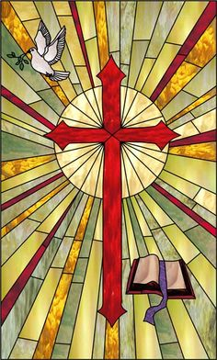

CHAPTER XVIII
The administration of Goods

179) The Order, as juridical entity, can acquire, administer, alienate and use temporal goods, in accordance with the law of the Order.

180) There shall be a Bursar or Financial Administrator for the Order as a whole. The Office of the Bursar shall not be held by Father Prior.

- The Bursar shall exercise his office in the service of the brethren, with attentive concern for all their needs, as the administrator of goods belonging to all, in a way that will help them to observe their poverty vow.

- The official representatives of the Order for the execution of any administrative, legal or financial act:
    - Father Prior
    - The Vice Father Prior
    - The Bursar

CHAPTER XIX
Departure and Dismissal from the Order

- Regarding temporary separation, that is, exclaustration, whether freely requested or imposed on a religious by Father Prior’s Office against his will, the norms of the law of the Order shall apply.

- An Apostle who, for a grave reason, requests to leave the Order during the time of his temporary profession may be granted the appropriate indult by Father Prior, with the consent of his Council.

- At the end of his temporary profession, the Apostle is free to leave the Order. Likewise, for a just reason, and following consultation with his Council, Father Prior may deny him further profession.

- Any physical or psychological infirmity which, in the opinion of experts, renders the Apostle mentioned in the previous article unsuited to life in the Order, even if such infirmity was contracted after profession, is sufficient reason for not admitting the Apostle to the renewal of temporary profession to solemn profession, unless the infirmity was contracted through negligence on the part of the Order or because of work performed within the Order.

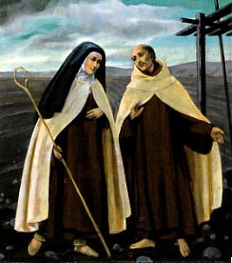

- If, however, a professed member in temporary vows should become insane, he shall not be dismissed from the Order, even if he should be incapable of making his profession.

- A member is ipso facto dismissed from the Order for different reasons, provided they are serious, external, imputable and juridically proven.

- With legitimate dismissal, the vows and any rights and obligations deriving from profession cease ipso facto. However, if the dismissed brother is a cleric, he many not exercise Holy Orders until he has found a bishop who will accept him or at least permit him to exercise his ministry.

- Brethren who have left the Order shall have no claims on the Order for any activity performed in its favor. Superiors, however, should feel themselves bound to contribute to their needs, in keeping with the statutes, especially at the beginning of their new way of life.



EPILOGUE

The brethren should make every effort to ensure that the charisma and
Spirituality of the Reformed Carmelites of the Divine Mercy,
as outlined in these Constitutions,
becomes the very wellspring of their lives.
Engaged in a single, fleeting journey on this earth, they are to be like
Exiles in a foreign land; their homeland is in heaven.
They should join then with all the saints in striving to understand every measure of Christ´s love, which surpasses all knowledge,
and aflame with burning love and ardent desire,
In aspiring to reach that place which the Lord, on leaving this world,
Promised to prepare for us. Let them be rooted and strengthened in love, ever vigilant,
lighted torches in their hands; increasing their talents so that, at the hour of their
death, they may be worthy to hear the consoling words of the Lord as he returns:
¨Well done, good and faithful servant! ¨

Given on the 14th day of November of the year of the Lord 2010.
Revised and approved on the 13th day of May of the year of the Lord 2026
Feast of Our Lady of Fatima

Carmelite Friars of the Divine Mercy
APOSTLES OF MERCY
Reformed Catholic Church for the Americas

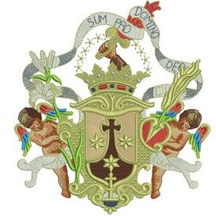

St. Elijah’s Monastery
Formation and General House
Fr. José Israel de la Trinidad, PhD., DD. AoM
Prior General
6255 Telegraph Road – Lot 125
Erie, Michigan 48133-9426
Tel: +1 (734) 775-9168

Email: frjoseisrael@gmail.com
Website: www.rcc-carmelitefriars.org

